4 RESULTS AND DISCUSSION
This chapter presents the results of the study in the order of the four specific objectives in Section 1.2: the analysis of existing practices (4.1), the development of the system (4.2), pilot testing (4.3), and evaluation and optimization against ISO/IEC 25010 (4.4), followed by the deployment plan (4.5). Testing and evaluation follow one family of standards, ISO/IEC 25000 (SQuaRE), as declared in Section 3.3: the quality model of ISO/IEC 25010:2011, its measures in the manner of ISO/IEC 25023 and 25022, and the evaluation process of ISO/IEC 25040. Every quality characteristic is judged on two kinds of evidence, what was measured in testing and how the system's users rated it.
4.1 Analysis of Existing Apartment Management Practices and System Requirements
Answers Objective 1.
The Fe Galang Da Silva Boarding House has 33 rentable units in five clusters: the Boarding House (22 units), the Back Apartment (5), the Front Apartment (3), the Penthouse (1) and Linda (2), on three residential floors and a rooftop penthouse level (11, 11, 10 and 1 units). At the time of writing, 32 of the 33 units are occupied. The owner confirmed these figures on 13 September 2026, and they are checked against the live records on every verification run.
4.1.1 Existing Practices and Identified Problems
Before the system, the owner kept a spreadsheet workbook with two sheets, a Monthly Income Report and a Monthly Expenses Report, on a USB flash drive, together with a paper invoice book. Rent was collected in cash on site, and requests arrived by messaging application or in person. Table 5 compares each practice with the problem it caused. Inquiries arrived much as Pernate et al. (2025) found for boarding houses in Ormoc City, through social media and word of mouth, and left no record.
Table 5. Existing practices and identified problems
Area | Existing practice | Problem identified
Tenant management | Tenant details kept in the income sheet and in the owner's memory | No single record of who lives in which unit, since when, or how many occupants
Financial tracking | Income and expense sheets typed by hand; invoices written in a paper book | Totals depend on manual arithmetic; nothing checks an invoice number against the book; one file on a USB flash drive is the only copy
Communication | Requests sent by messaging application or said in person | Requests are not recorded, so there is no way to follow a request to completion
Booking | Inquiries arrived through Facebook, referrals from other people, contact and text messages, or walk-ins in person | No record of inquiries or which unit an inquiry was about

Figure 4 follows each area through the hands that touched it. Every path ends in a record kept apart from the others, or in no record at all, which is where each problem in Table 5 begins.
Figure 4. The owner's process before the system.
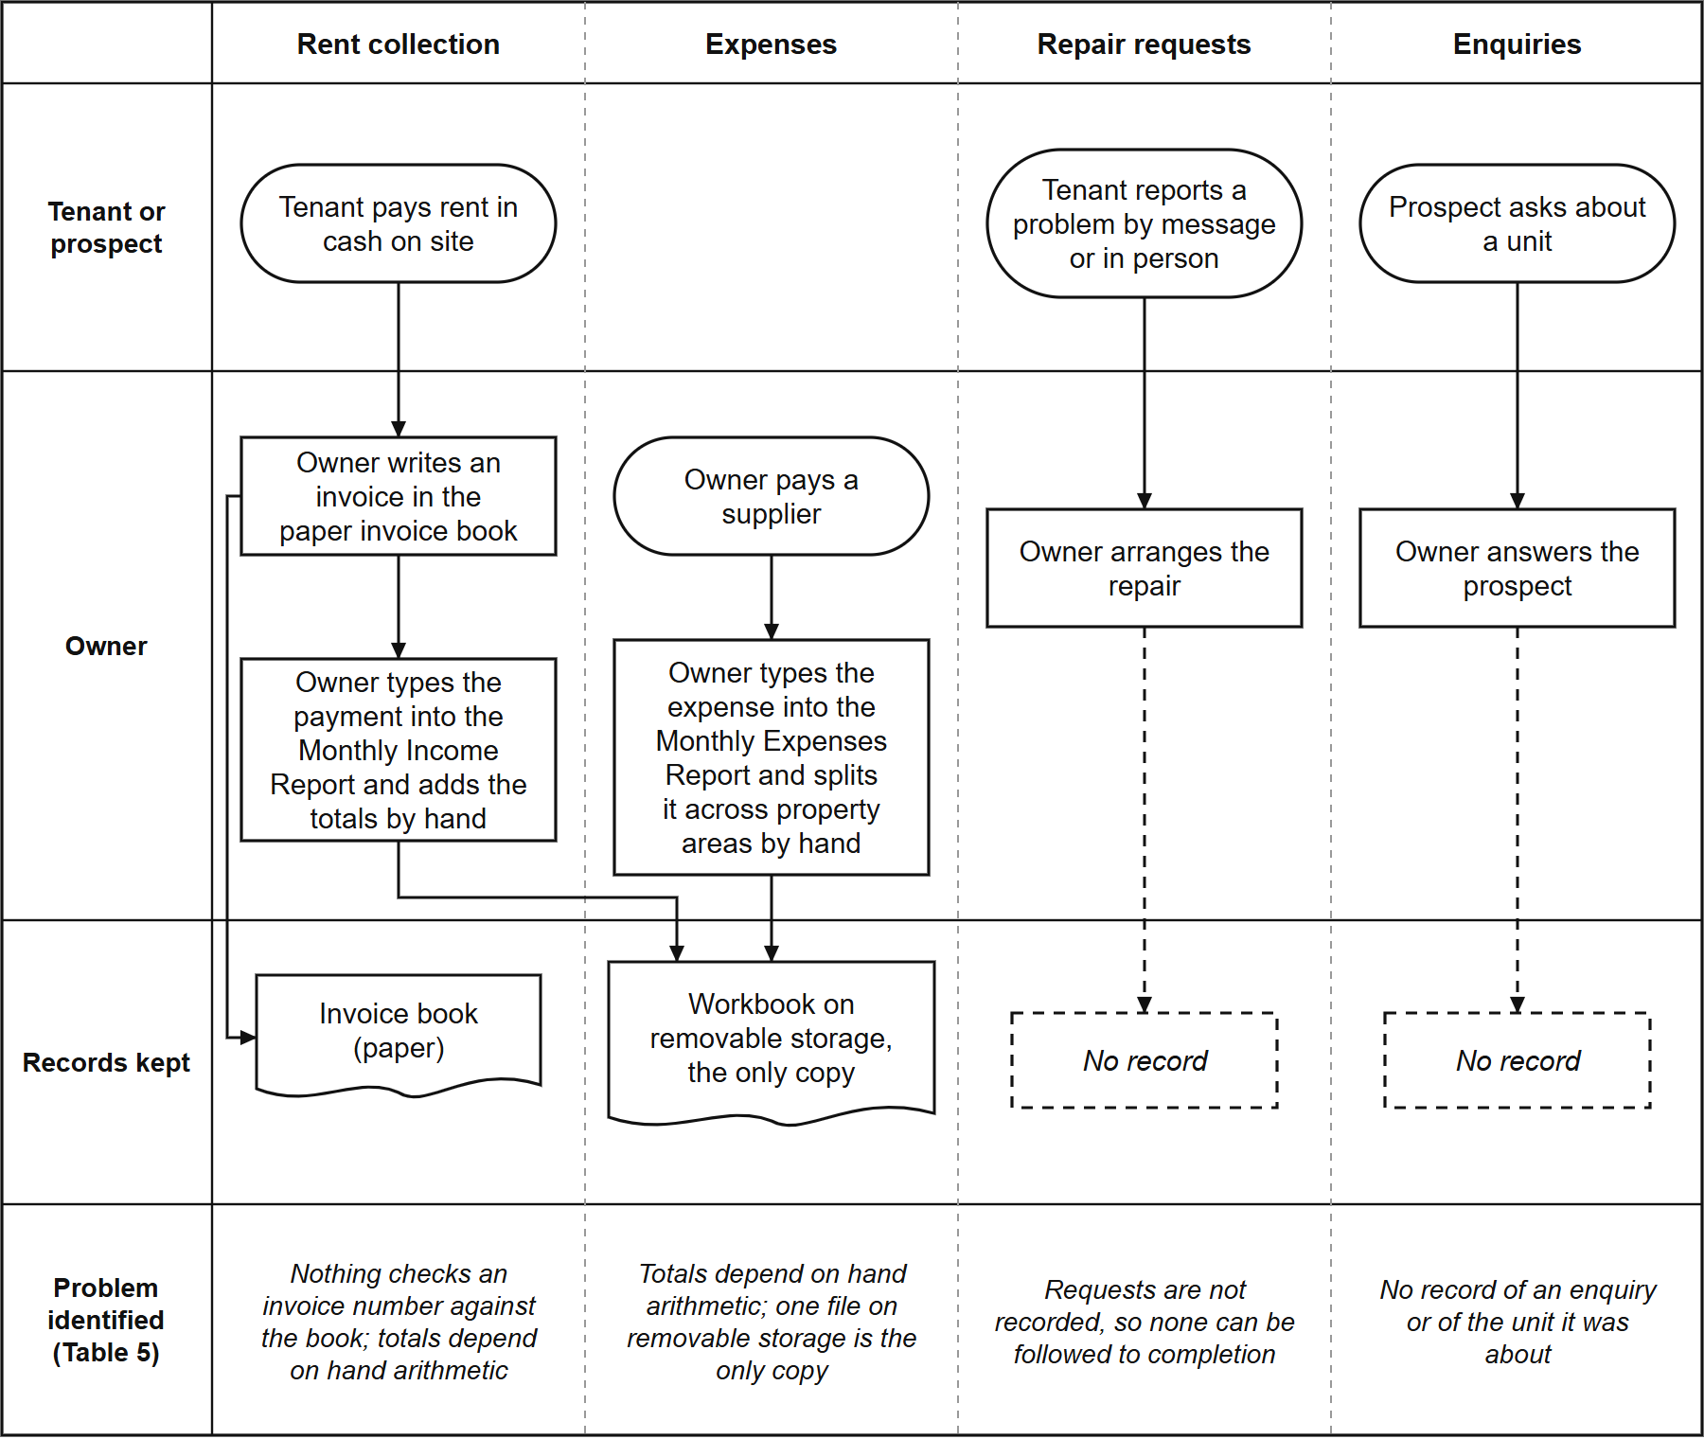
The strongest evidence came from the owner's own records. Transferring her workbook into the system (937 income rows and 1,327 expense allocations) exposed problems the spreadsheet had hidden: 402 of the 937 income rows (43%) had no anniversary date and no deposit, and five invoice numbers were each used for two different payments, once for two tenants on the same day. They were kept exactly as she wrote them and are reported on every verification run. The decisive finding is that the problems did not sit in one area: each area kept its own informal record, and nothing connected one to another, the fragmentation described in Chapter 2 (Burke, 2026; Magno et al., 2024).
4.1.2 System Requirements
The analysis produced 44 functional requirements and 49 business rules, each traced in a traceability matrix to the part of the system that implements it. Graded against the code on 16 September 2026, 25 of the 44 were implemented as worded, 15 in part, 1 in the interface only, and 3 not as worded, although what those three describe is visible to the owner in another form. Table 6 traces each gap to the requirement and the module that meets it.
Table 6. Identified gaps, system requirements and implementing modules
Identified gap | System requirement | Module (Section)
No single tenant and unit record | Keep one record per unit and per tenant, with occupancy and move-in dates | Tenant and Room Management (4.2.2)
Inquiries not recorded | Let the public view units and send an inquiry about a specific unit | Booking and Reservation (4.2.3)
Manual arithmetic and unchecked receipts | Compute charges, record payments against the owner's own invoice numbers, reproduce the owner's reports | Financial Tracking (4.2.4)
Cash only, no digital option | Offer an optional online payment that the owner verifies before it counts | Financial Tracking (4.2.4)
Requests not followed to completion | Record each request and its status until the owner closes it | Maintenance Ticketing and Notification (4.2.5)
Anyone with the file sees everything | Give the owner and each tenant access to only what their role needs | Role-Based Access Control (4.2.6)
One file on one device | Make the system reachable from any phone or computer | Progressive Web Application (4.2.7)

The analysis also set ten non-functional requirements, one for each ISO/IEC 25010 characteristic and two for auditability and exportability. Table 6B lists them with the section that reports how each was met.
Table 6B. Non-functional requirements and where each is measured
Code | Requirement | Measured in
NFR-001 | The system shall provide the required business functions accurately | Sections 4.3.1 to 4.3.4; Section 4.4.3
NFR-002 | The system shall be understandable to a non-technical administrator | Section 4.3.7; Section 4.4.3 (Usability)
NFR-003 | The system shall protect personal and financial information | Section 4.2.6; Section 4.4.4
NFR-004 | Common operations should respond efficiently under the expected workload | Tables 11 and 11B
NFR-005 | The system shall function on modern desktop and mobile browsers | Table 24; Section 4.4.3 (Compatibility)
NFR-006 | The system shall preserve data consistency and avoid silent data loss | Sections 4.3.1, 4.3.3 and 4.3.6 (Table 11F)
NFR-007 | The codebase shall use a modular, documented, maintainable architecture | Section 4.4.3 (Maintainability): partly met
NFR-008 | The system shall be deployable to a hosting environment the team can maintain | Section 4.2.1; Table 24
NFR-009 | Important financial and administrative changes shall be traceable | Section 4.2.6 (audit trail)
NFR-010 | Relevant business data shall be usable outside the application | Section 4.2.4 (Excel downloads)

NFR-008 originally named the university's server; on the adviser's advice the team deployed the system on its own hosting instead (Section 3.2.5), and the requirement was reworded to match.
Where a requirement needed the owner's answer, it was asked rather than assumed. She confirmed that a bill is overdue from the day after its due date, that she sets rates by hand (so every rate change is recorded and no increase is applied automatically), that a tenant needs no email address to be recorded, and on 20 September 2026 the rate of every unit, each of which agreed with her receipts. Her answers of 12 October 2026 settled the rest: the figure at the bottom of her income sheet is a year-to-date total; her thirteen expense categories stay and she may add her own; tenants do not report cash payments, because the administrators record every payment; the personal spending booked in 2025 was a renovation of her house; past Penthouse spending stays where it was filed; and three months with no receipt for one unit stay blank. Her workbook never recorded the move-in date of each current tenancy, so the system shows those dates as not recorded (Section 4.2.2).
4.2 Development of the Hivelet System
Answers Objective 2. Each feature the objective names has its own subsection.
Figures 5 to 9 model the system as built, and Figures 10 to 14 show its screens as they stood on 5 October 2026. The units, rates and statuses in Figures 10 and 11 are the property's own; the names, payments, expenses and repair requests in Figures 10, 12, 13 and 14 are sample records, so that no real tenant's name or payment appears in any figure.
4.2.1 System Architecture and Technology Stack
The system was built in three Agile iterations (Section 3.2). The first (24 July to 28 August 2026) built a working system and transferred the owner's records into it; the second (12 to 14 September) checked the system and its documents against each other, corrected 22 recorded errors and added automated checks; the third (15 September to the defense) took the owner's answers, put the system in her and her tenants' hands, and refined it from their feedback, the testing and the evaluation. Appendix M, Table M-19, sets out what each iteration did in each phase of Section 3.2. Each was tested and reviewed by the means available to it; the formal evaluation against ISO/IEC 25010 was carried out once, in the third, because Section 3.3 places it in actual use. Table 7 lists the technology used.
Table 7. Technology stack of the developed system
Layer | Technology | Purpose
Presentation | Vue 3.5 with TypeScript 5.7, built with Vite 5.4, styled with Tailwind CSS 4.0 | The screens used by the public, tenants and the owner
Application | Node.js with Express 4.19 in TypeScript | Business rules, calculations and access checks
Data | PostgreSQL 17.6, hosted on Supabase | Storage of all records, with row-level security
Payment gateway | Adyen (Web Drop-in 6.44, API Library 32.0) with GCash | The optional online payment
Client delivery | Progressive Web Application (vite-plugin-pwa) | Installation on a phone or computer without an app store
Hosting | Vercel | Serves the application at a public web address

Figure 5 shows where each part runs. The application reaches the browser as a Progressive Web Application and talks to one server program, an Express API on Vercel, which alone reads or writes the database: row-level security is on for every table, so a request that does not pass the API's sign-in and role checks reaches no data. Payment details go from Adyen's own form to Adyen directly, and every change to the database is a numbered, reviewable migration. The system is hosted rather than run on a server at the property or the university: on the adviser's advice the team deployed it on its own hosting (Section 3.2.5), so the boarding house needs no equipment beyond the owner's own laptop and phone.
Figure 5. System architecture.
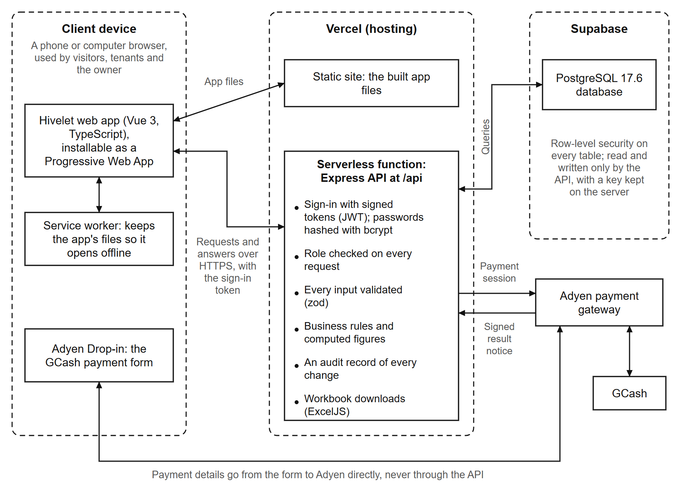
Figure 6 is the context diagram: the system as one process, with the four parties outside it and the data that passes between them. Figure 7 opens it into eight processes and the stores each reads and writes, in the Yourdon-DeMarco notation. To trace one path: the owner records a cash receipt through process 4.0, Bill and record payments, which writes it to store D3, Bills and receipts, and process 7.0, Produce reports, reads it from there for the Overview and the Excel workbooks. The notifications and the audit record are written by nearly every process and are left out of Figure 7 for readability.
Figure 6. Context diagram.
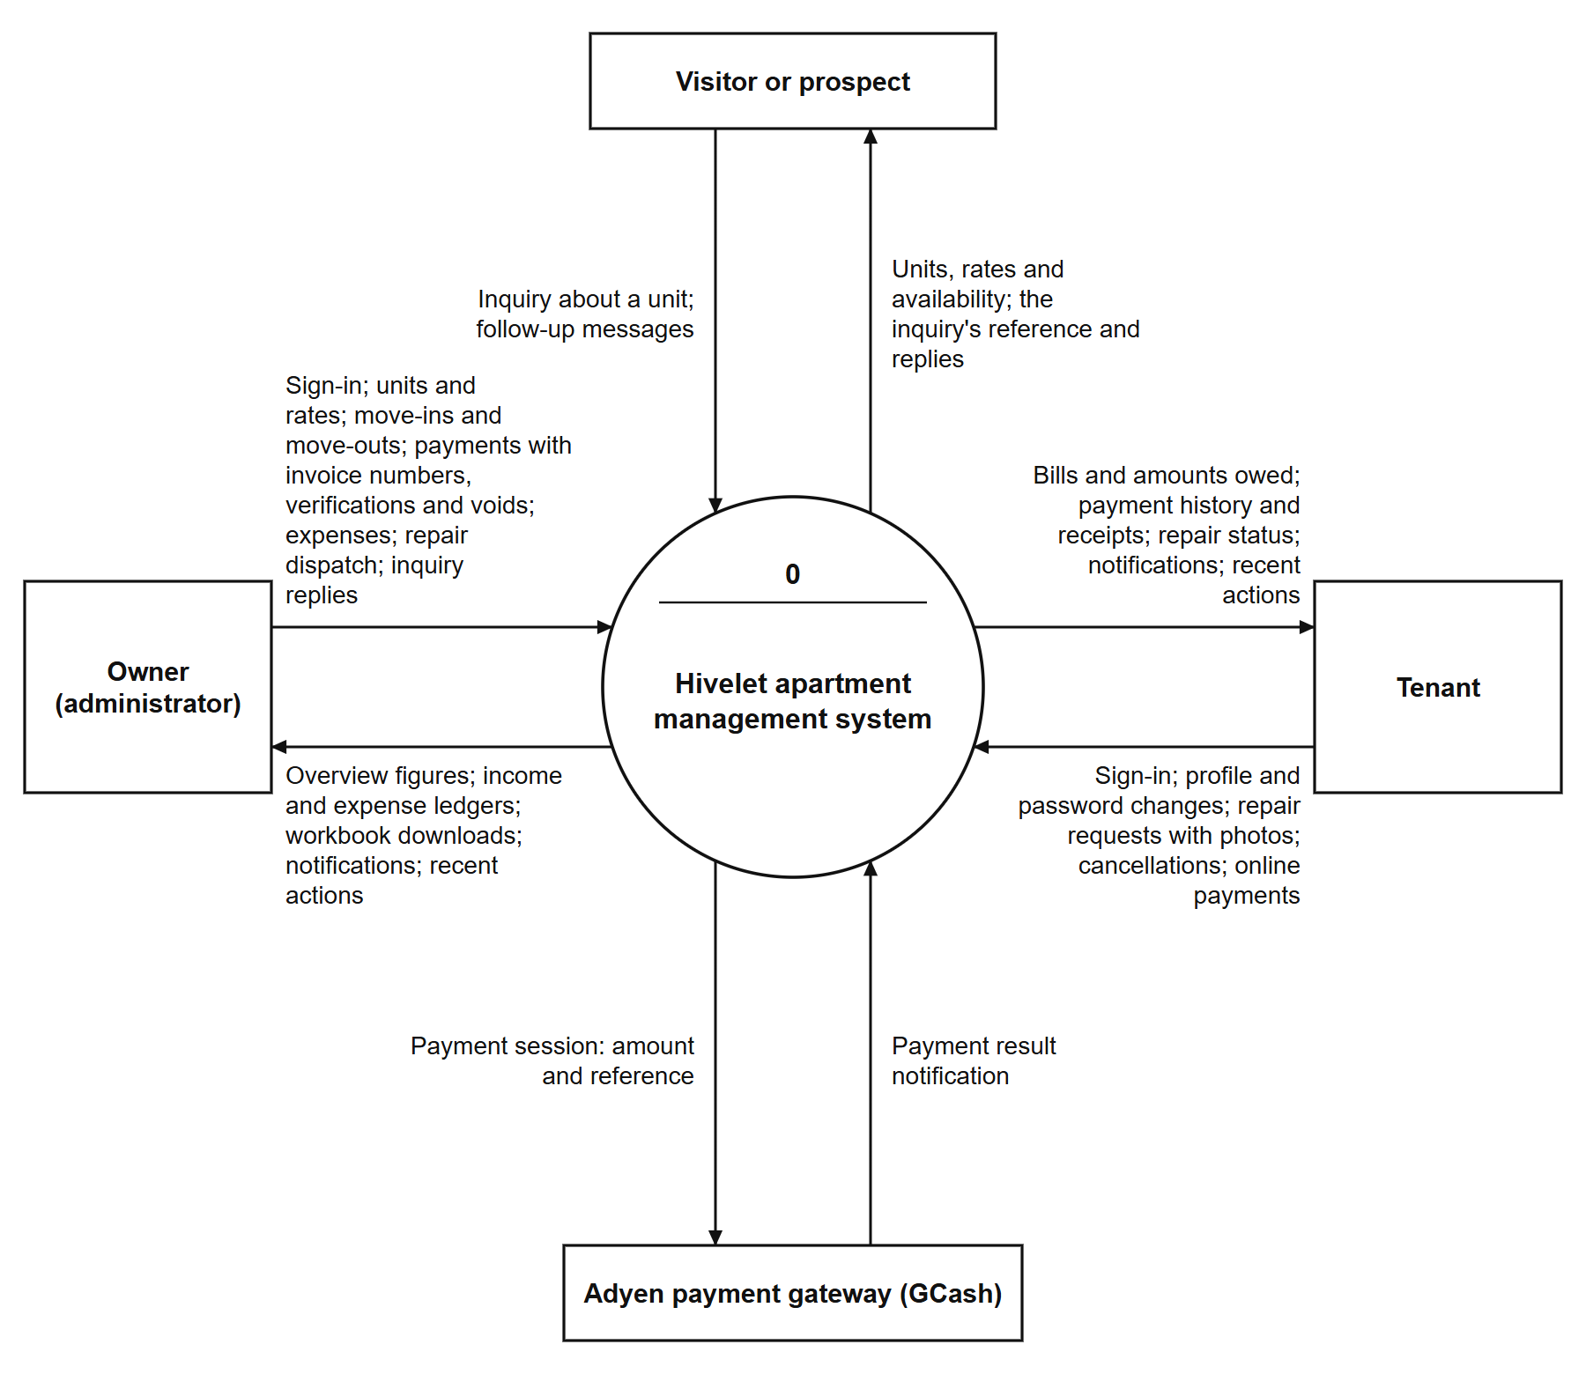
Figure 7. Level 1 data flow diagram.
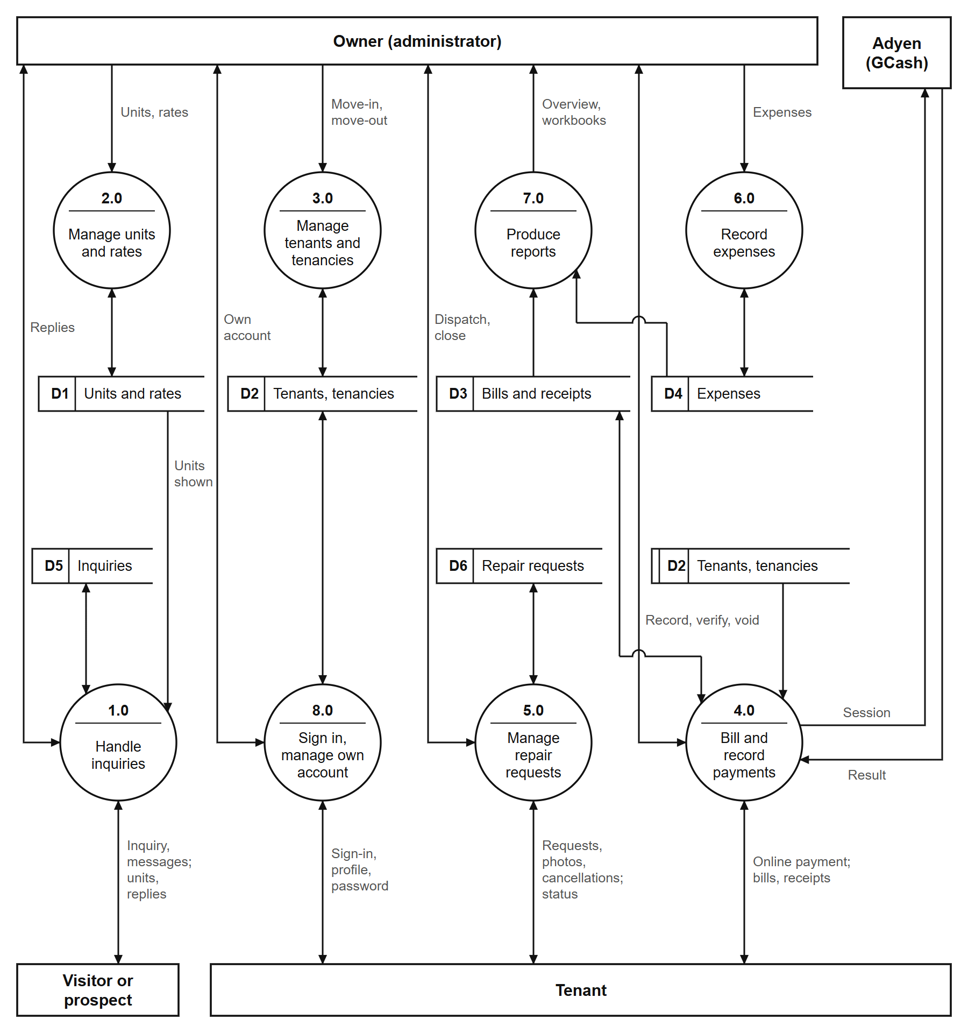
Figure 8 shows the same functions from the side of the people who use them. Each use case is a function the server grants to that role and refuses to every other (Table 7C).
Figure 8. Use case diagram.
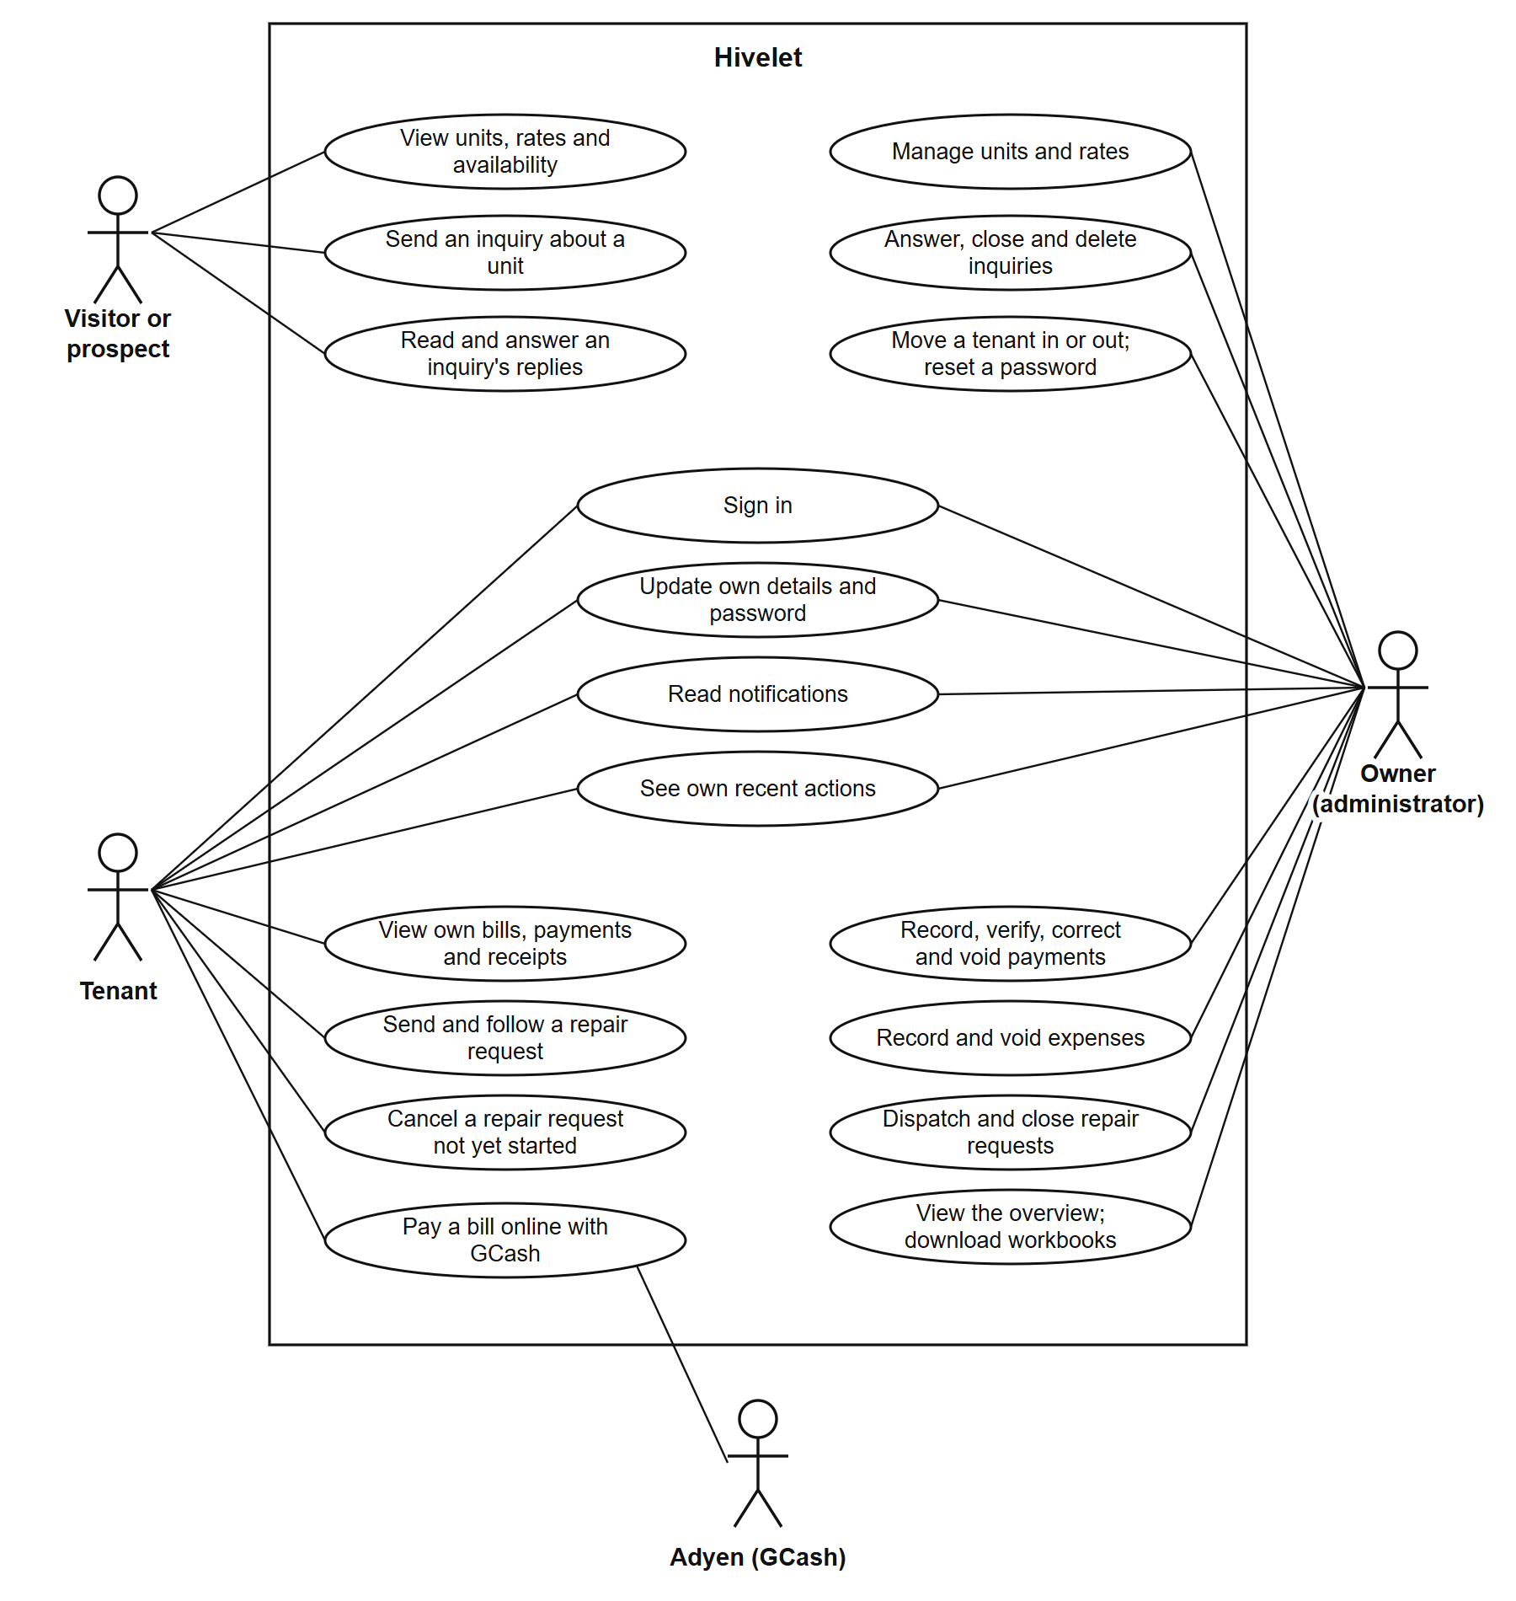
Figure 9, in Crow's Foot notation, is the entity-relationship diagram drawn from the database's own catalogue on 5 October 2026: 21 tables, each with a primary key, and 37 foreign keys. Rooms and profiles are its two centers: every bill, payment, receipt, tenancy, repair request and inquiry belongs to one unit, and every tenancy, bill and payment to one person. The two ledgers are kept as the owner kept them. Several rules live in the database itself, so no screen or script can bypass them: one unit cannot have two active tenancies, one invoice number cannot be used twice for the same unit and month, a gateway reference cannot be recorded twice, and the 50% Share and the remitted amount are computed columns. Table 7A is an extract of the data dictionary for the table the owner reads most; the complete dictionary, every column of all 24 tables, is in Appendix N.
Figure 9. Entity-relationship diagram.
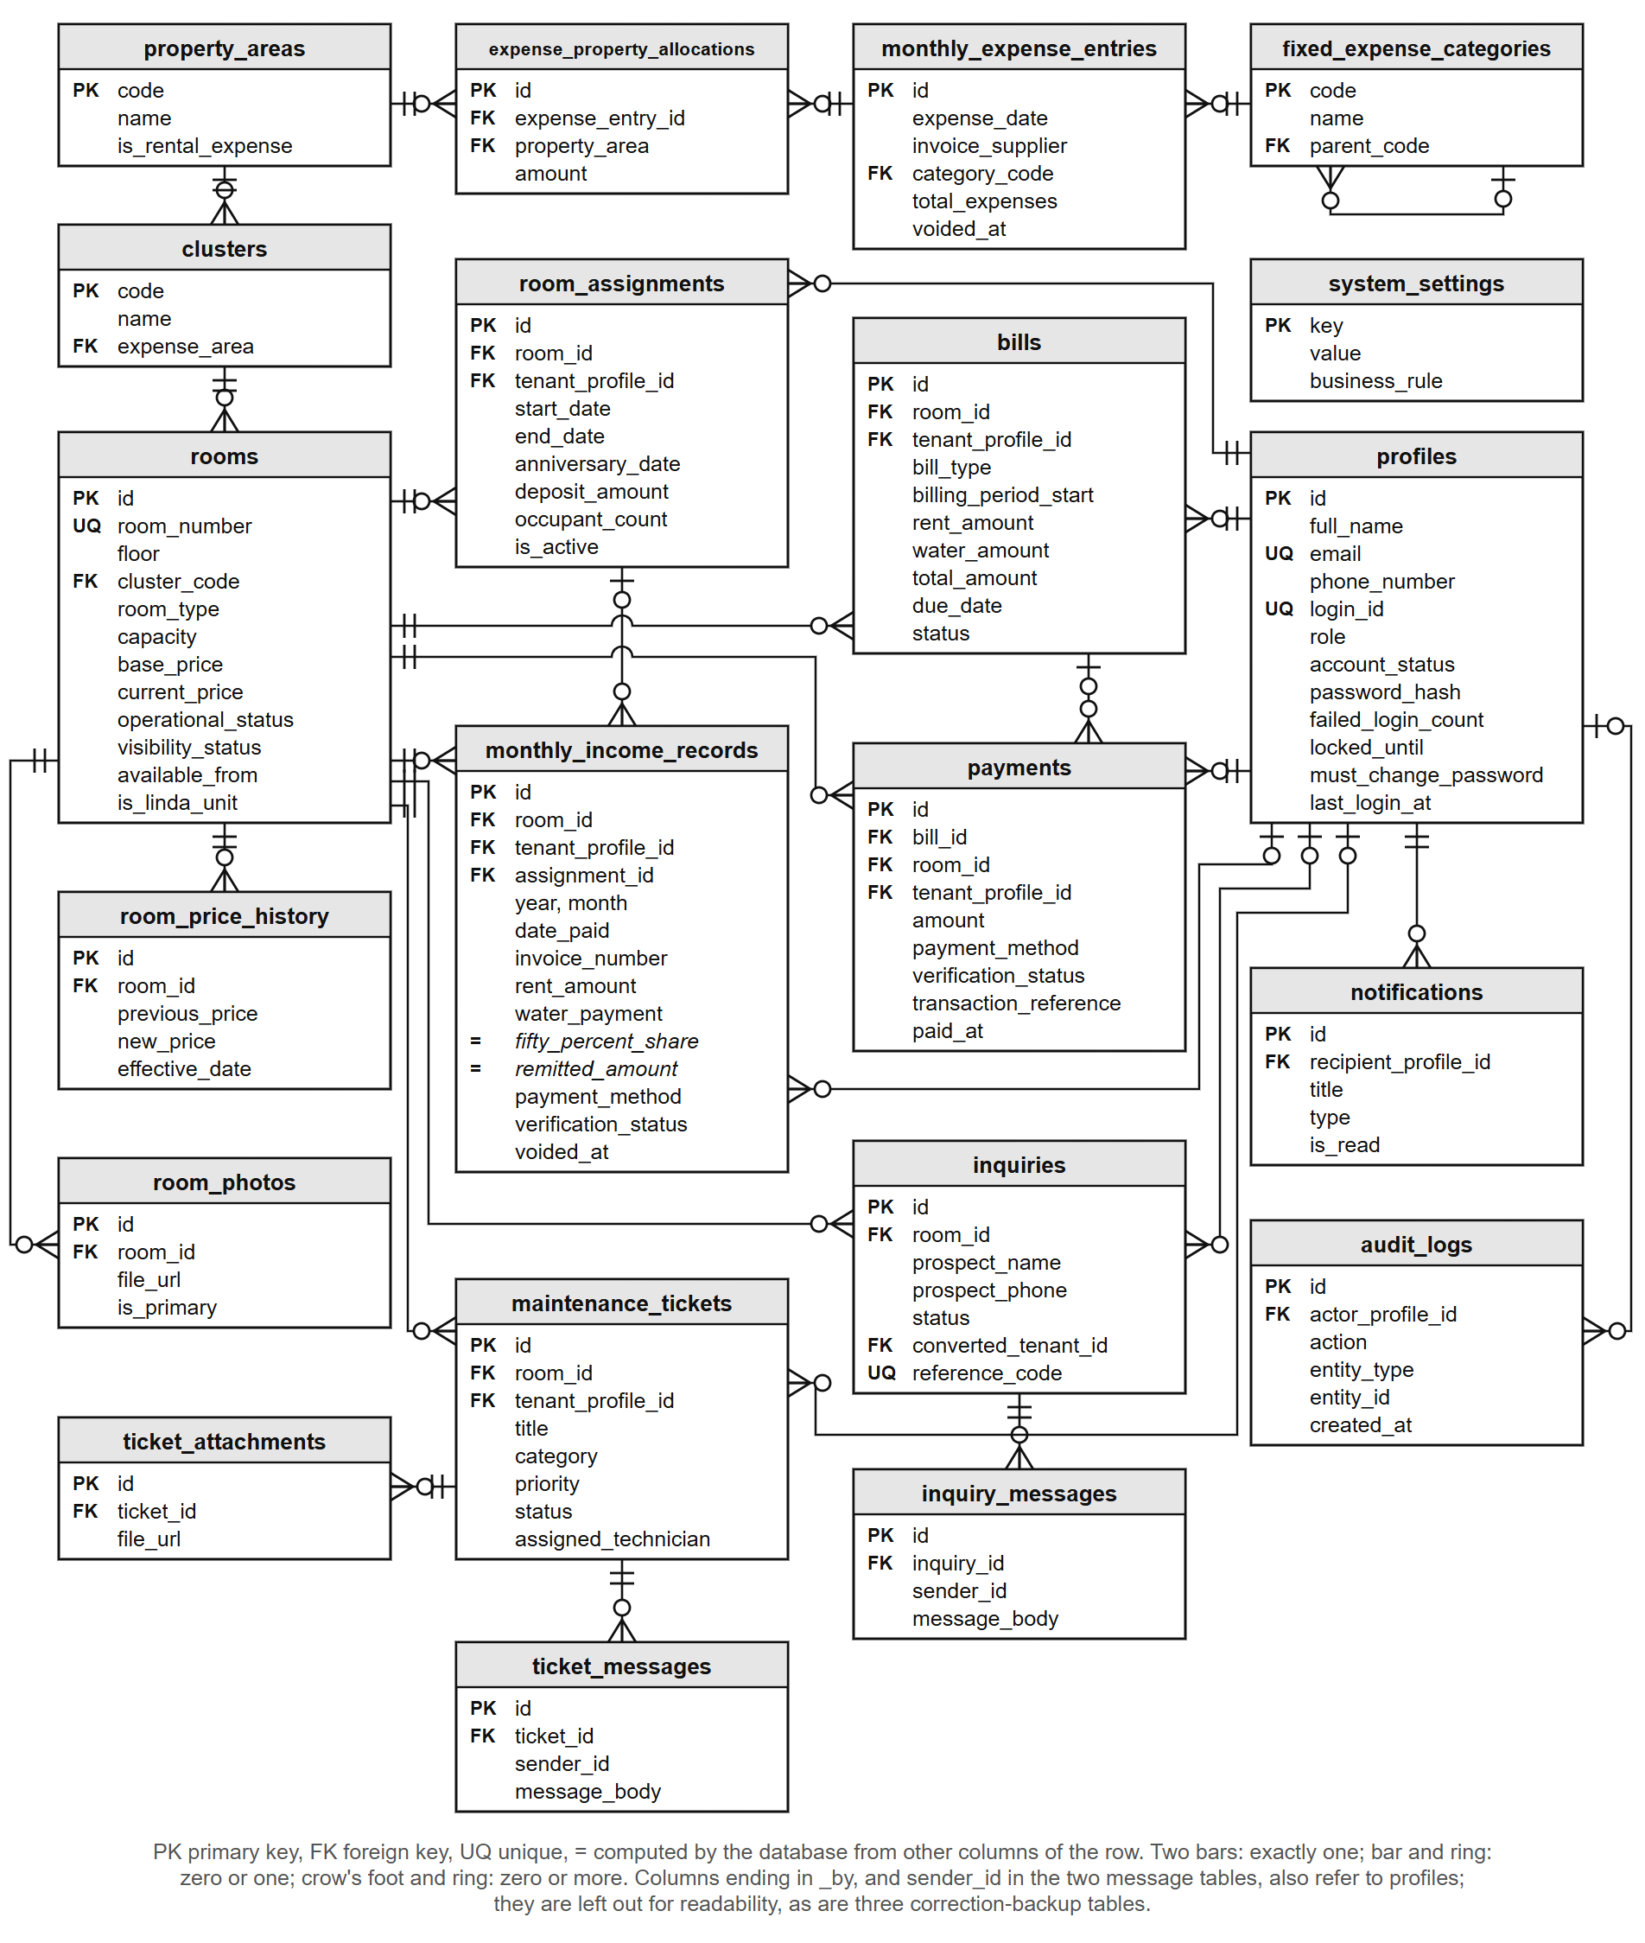
Table 7A. Data dictionary extract: monthly income records
Column | Type | Null | Key | Description
id | uuid | No | PK | Identifies the receipt
room_id | uuid | No | FK | The unit the payment is for (rooms)
tenant_profile_id | uuid | Yes | FK | The tenant who paid, where one is recorded (profiles)
assignment_id | uuid | Yes | FK | The tenancy the payment belongs to, where known (room_assignments)
year, month | integer | No |  | The ledger month the receipt is filed under
date_paid | date | No |  | The day the money was received
contact_name | varchar(255) | No |  | The name as written on the receipt
invoice_number | varchar(100) | Yes |  | The owner's own invoice number; not repeated for the same unit and month among receipts that are not voided
rent_period_start, rent_period_end | date | No |  | The period the rent covers (BR-033)
rent_amount | numeric(10,2) | No |  | The rent received
occupants | integer | No |  | The number of occupants that month
water_payment | numeric(10,2) | No |  | The water fee, ₱200 per occupant (BR-014)
fifty_percent_share | numeric(10,2) |  | Computed | A system-computed figure equal to half the row's Rent Amount, kept for ledger parity with the owner's historical spreadsheet (BR-035)
remitted_amount | numeric(10,2) |  | Computed | Rent Amount plus Water Payment (BR-038)
payment_method | enumeration | No |  | Cash, GCash, Bank Transfer or Adyen Online
verification_status | enumeration | No |  | Verified, Pending Verification or Rejected
transaction_reference | varchar(120) | Yes |  | The gateway's reference for an online payment; never recorded twice
is_linda_billing, linda_water_charge, linda_electricity_charge | boolean, numeric(10,2) | Yes |  | The two Linda units' charges, recorded separately (BR-040)
voided_at, voided_by, void_reason | timestamp, uuid, text | Yes | voided_by: FK | When, by whom and why a receipt was voided; a voided receipt is kept, never deleted
created_at, updated_at | timestamp | Yes |  | When the row was written and last changed

4.2.2 Tenant and Room Management Module
Figure 10 presents the Rooms and rates screen. Each unit carries its cluster, floor, current rate and status, and each tenancy the number of occupants, the move-in date and emergency contacts. When the owner changes a rate, a database trigger records the old rate, the new rate, the date and who made the change, so no path can change a rate without leaving that record. The owner's workbook did not record move-in dates, so for the transferred tenancies the screen says the date is not recorded rather than showing a guessed one. Since 13 October 2026 a tenant also sees the deposit held for their tenancy on their own Overview, as one tenant asked in the survey (Table 23).
Figure 10. Room and rate directory.
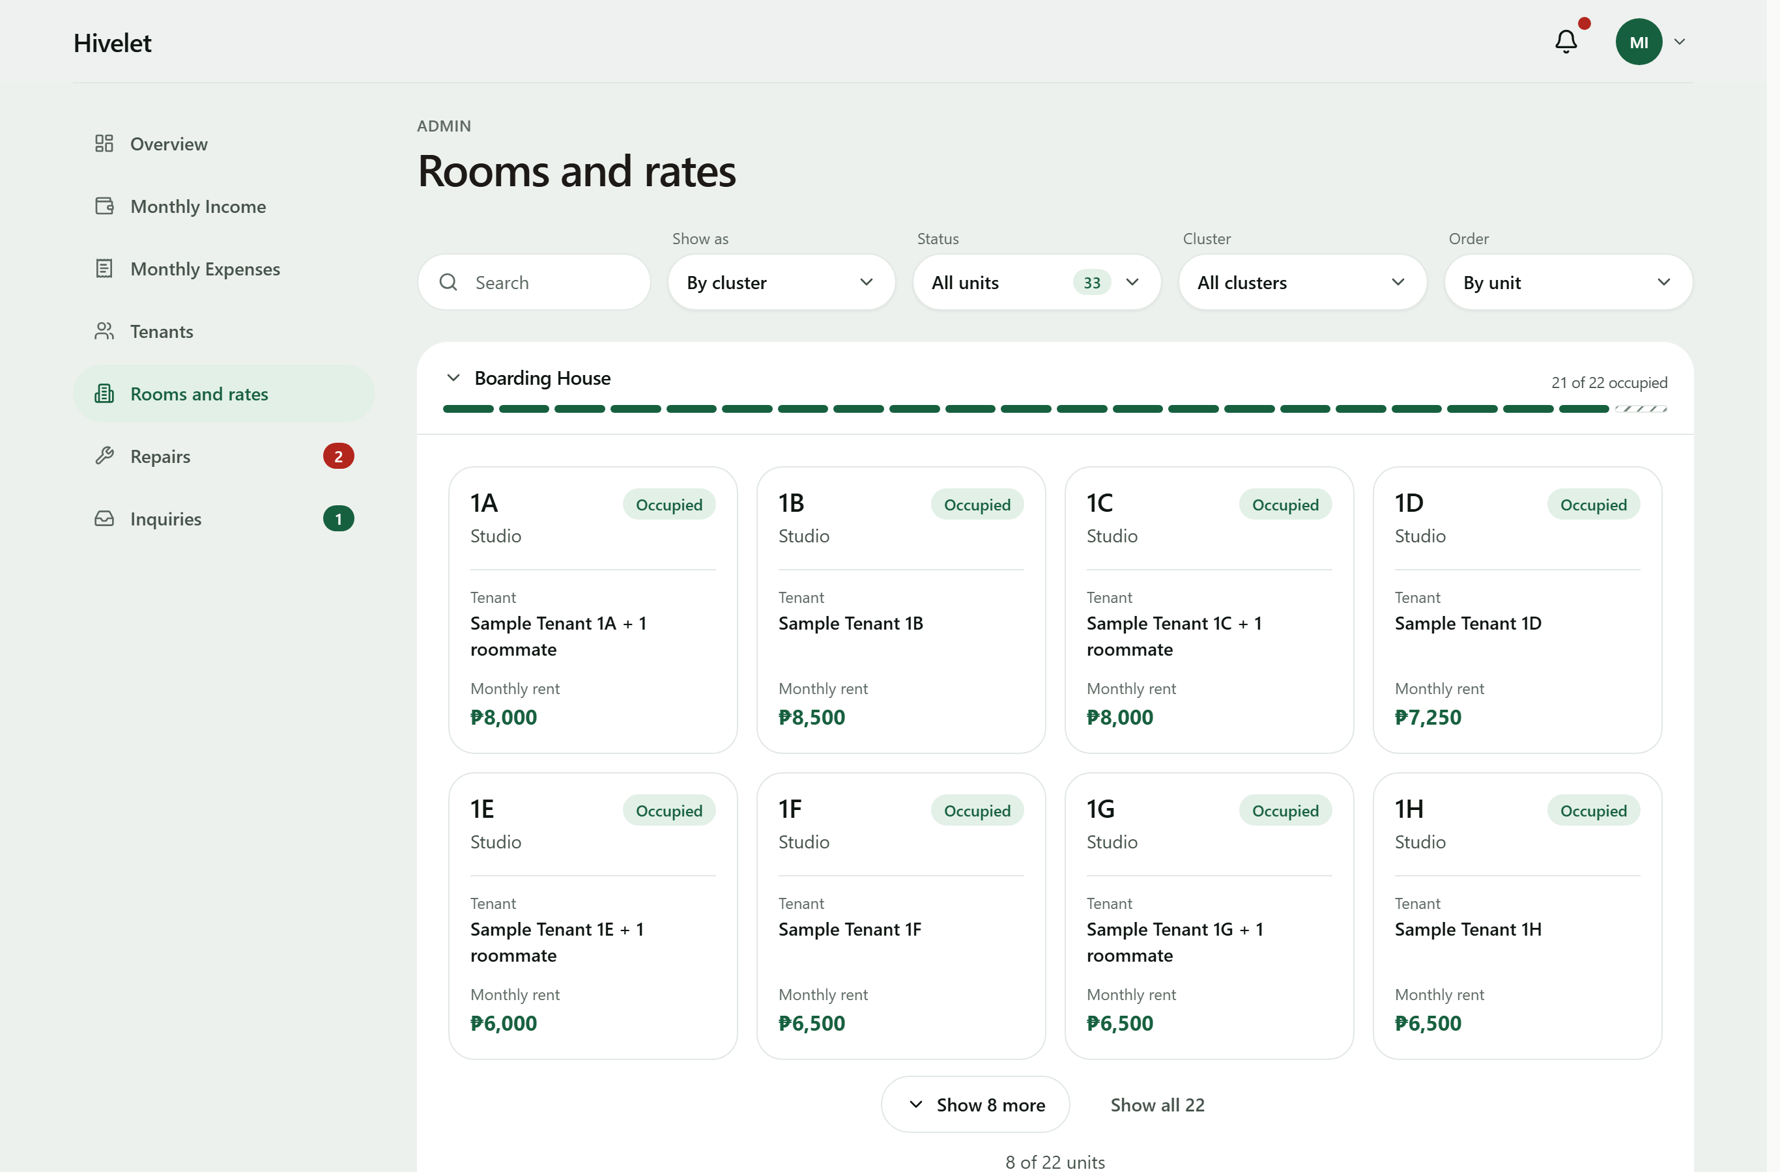
4.2.3 Booking and Reservation Management Module
Figure 11 presents the public unit catalogue and the inquiry form. A visitor sees each unit with its rate, read live from the database, and sends an inquiry about a specific unit without an account. On sending, the visitor receives a private link and a short reference code; either one (the code with the phone number given) opens the conversation, where the owner's answer appears and the visitor can write back. The link's secret is stored only in hashed form. An accepted inquiry becomes a tenancy linked to it, a reserved unit accepts no new inquiries, and the public site never shows a tenant's name, which is checked on every verification run against all 33 units.
Figure 11. Public unit catalogue (top) and inquiry form (bottom).
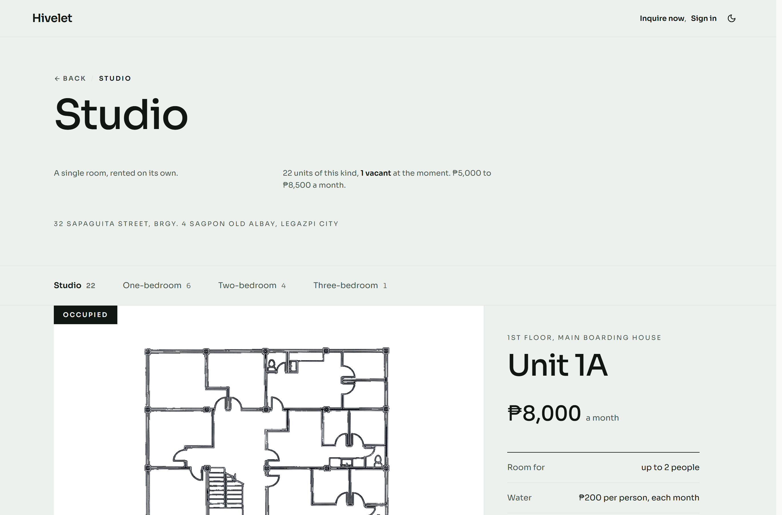
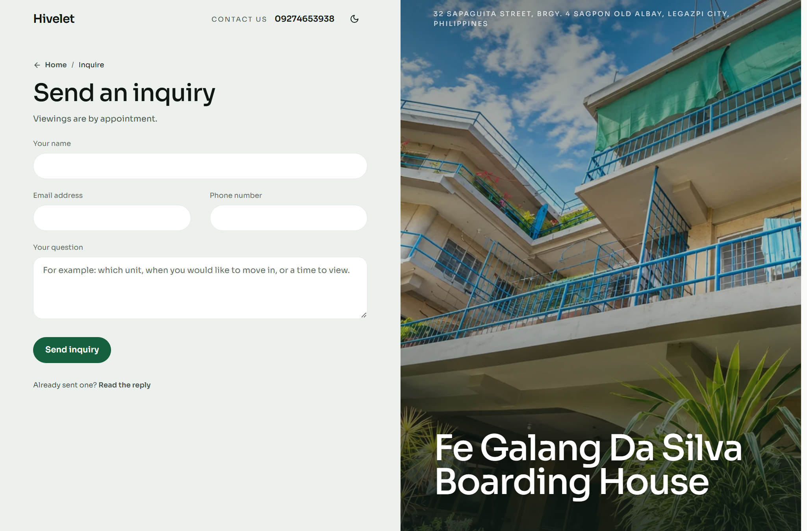
4.2.4 Financial Tracking and Payment Recording Module
Figure 12 presents the Monthly Income ledger. The owner records a cash payment with the number of the invoice she issued, or with none, since not every payment has one; the system never makes up an invoice number, and it warns her if the same tenant already has a payment for that month. The receipt is filed under the month the rent is for, not the day it was paid, and both ledgers keep her workbook's layout and download as Excel files in it. Online payments go through Adyen with GCash: a payment made this way enters Pending Verification and changes nothing on the tenant's bill until the owner verifies it. Tenants see the same record from their side, month by month, where only receipts the owner has verified count as paid and a month with no receipt is shown as "Not entered", never as owed, because the records alone cannot tell an unpaid month from one not yet entered. Electricity is outside the system: each unit has its own meter and the tenant pays the electric company directly.
Figure 12. The monthly income ledger.
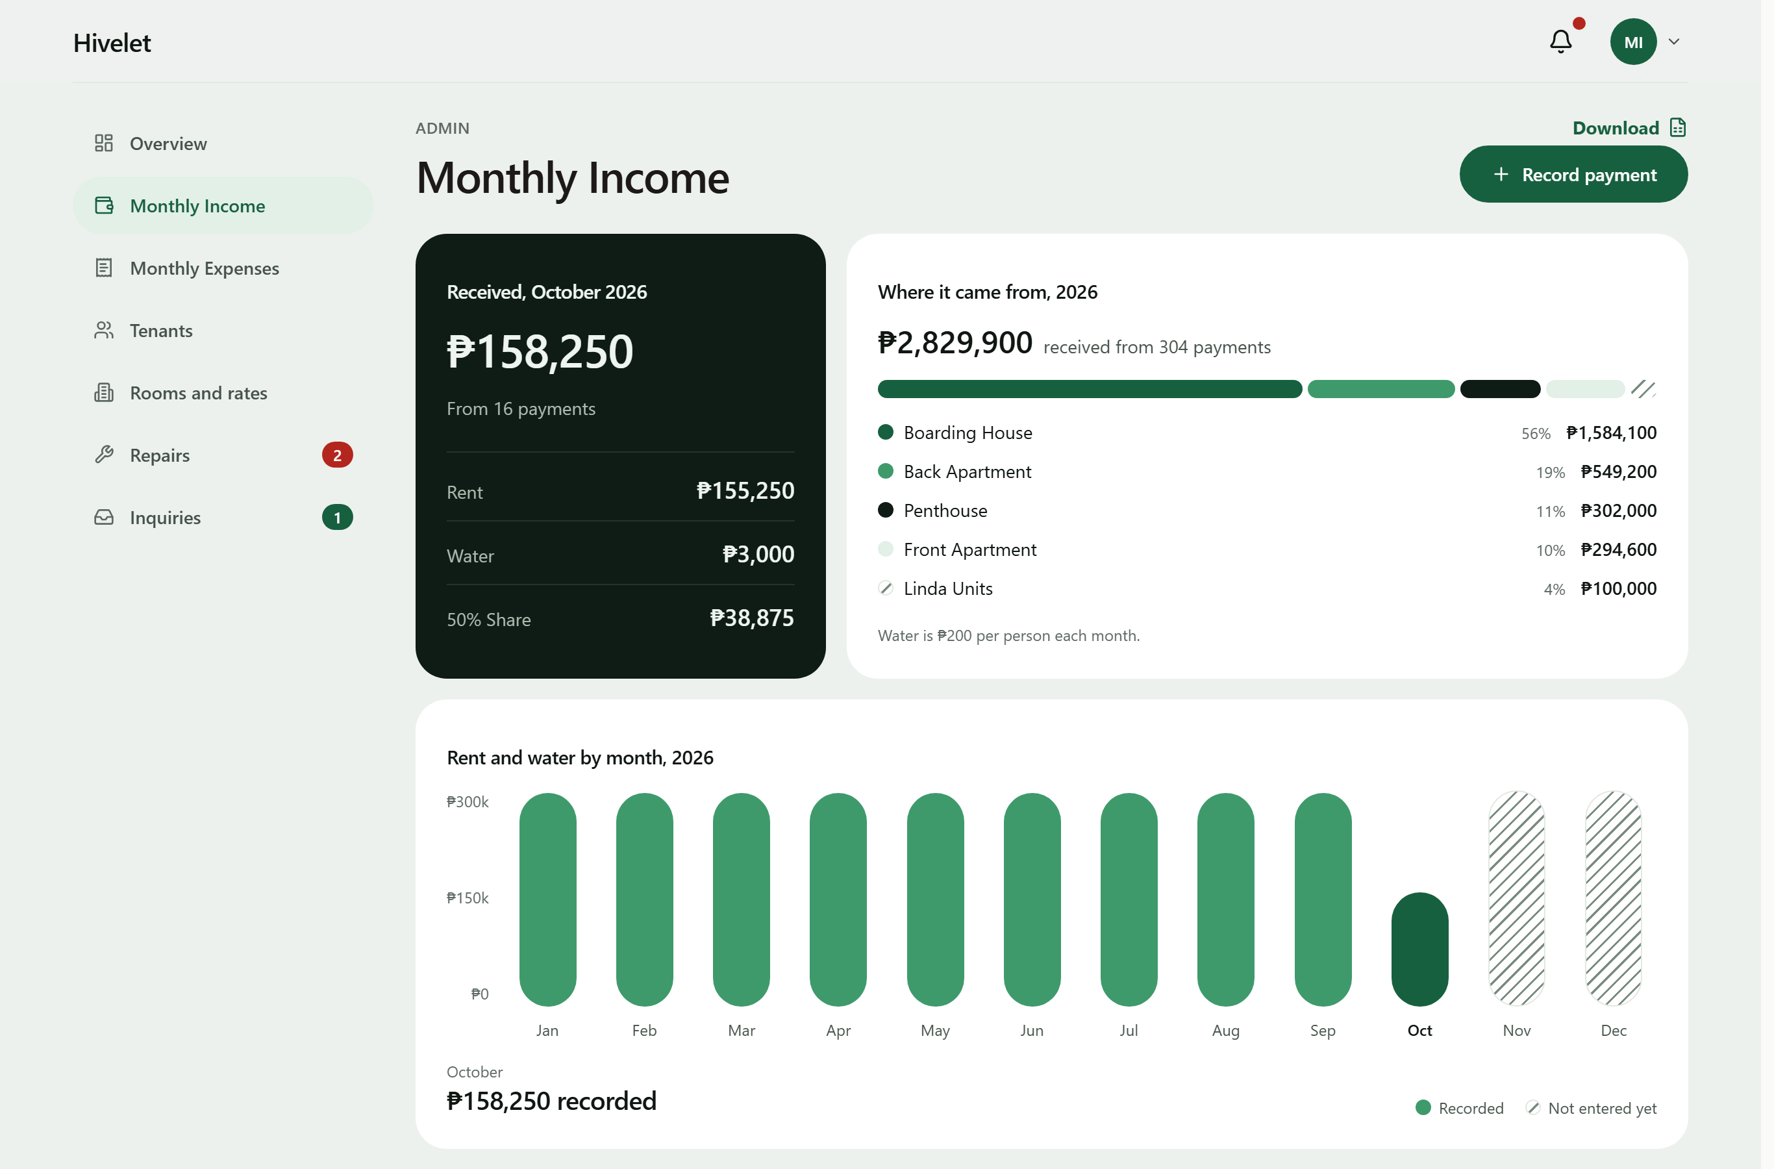
These results agree with Encarnacion et al. (2025) and Setty (2022), who found that one structured ledger improves oversight and reduces administrative errors, and add one observation: the consolidation also exposed errors already in the owner's records (Section 4.1.1). Every figure the owner reads is computed from the rules in Table 7B rather than typed, so the same inputs always give the same amount.
Table 7B. Business rules for computed figures, with a worked example
Rule | What the system computes | Worked example
BR-014 Water fee | Water = number of occupants × ₱200 | Unit 2C with two occupants: 2 × ₱200 = ₱400
BR-038 Remitted amount | Remitted = Rent Amount + Water Payment | ₱8,500 + ₱400 = ₱8,900
BR-035 50% Share | A system-computed figure equal to half that row's Rent Amount, kept for ledger parity with the owner's historical spreadsheet | ₱8,500 ÷ 2 = ₱4,250
BR-033 Rent period | The period a payment covers, from the tenancy's anniversary date | Anniversary on the 13th: rent for 13 August to 12 September
BR-010, BR-011, BR-012 Due date and overdue | Due on the date the billing cycle sets; overdue from the next day, with no grace period | Due 13 September: overdue from 14 September
BR-039 Deposit | Equal to the rent in effect at move-in, set once | Moved in at ₱8,500: deposit ₱8,500
BR-040 Linda's units | Water at the same ₱200 per occupant, recorded separately and kept out of the remitted amount | Unit LF with two occupants: ₱400 recorded as Linda's water; remitted = rent only
BR-045 Expense total | An expense entry's total = the sum of its allocations to property areas | ₱6,000 to the Boarding House + ₱2,000 to the Main House = ₱8,000

4.2.5 Maintenance Ticketing and Notification Module
Figure 13 presents the repairs board. A tenant submits a request with a title, description and priority, follows it through to completion, and may cancel it before work starts. The owner can also log a repair she is told about in person, including one for an empty unit. Only the owner closes a request, and the tenant is notified when it is done. In-app notifications also tell a tenant when a payment is verified or declined, and the owner when a payment, inquiry or comment arrives; opening one opens the record it is about. This is the change Saputra et al. (2025) report, in which complaints turned into traceable requests improved accountability, and it bears on the responsiveness Jing and Lim (2021) found central to residents' satisfaction: a request now carries its status from submission to closing, where before it left no record (Figure 4).
Figure 13. Maintenance requests board.
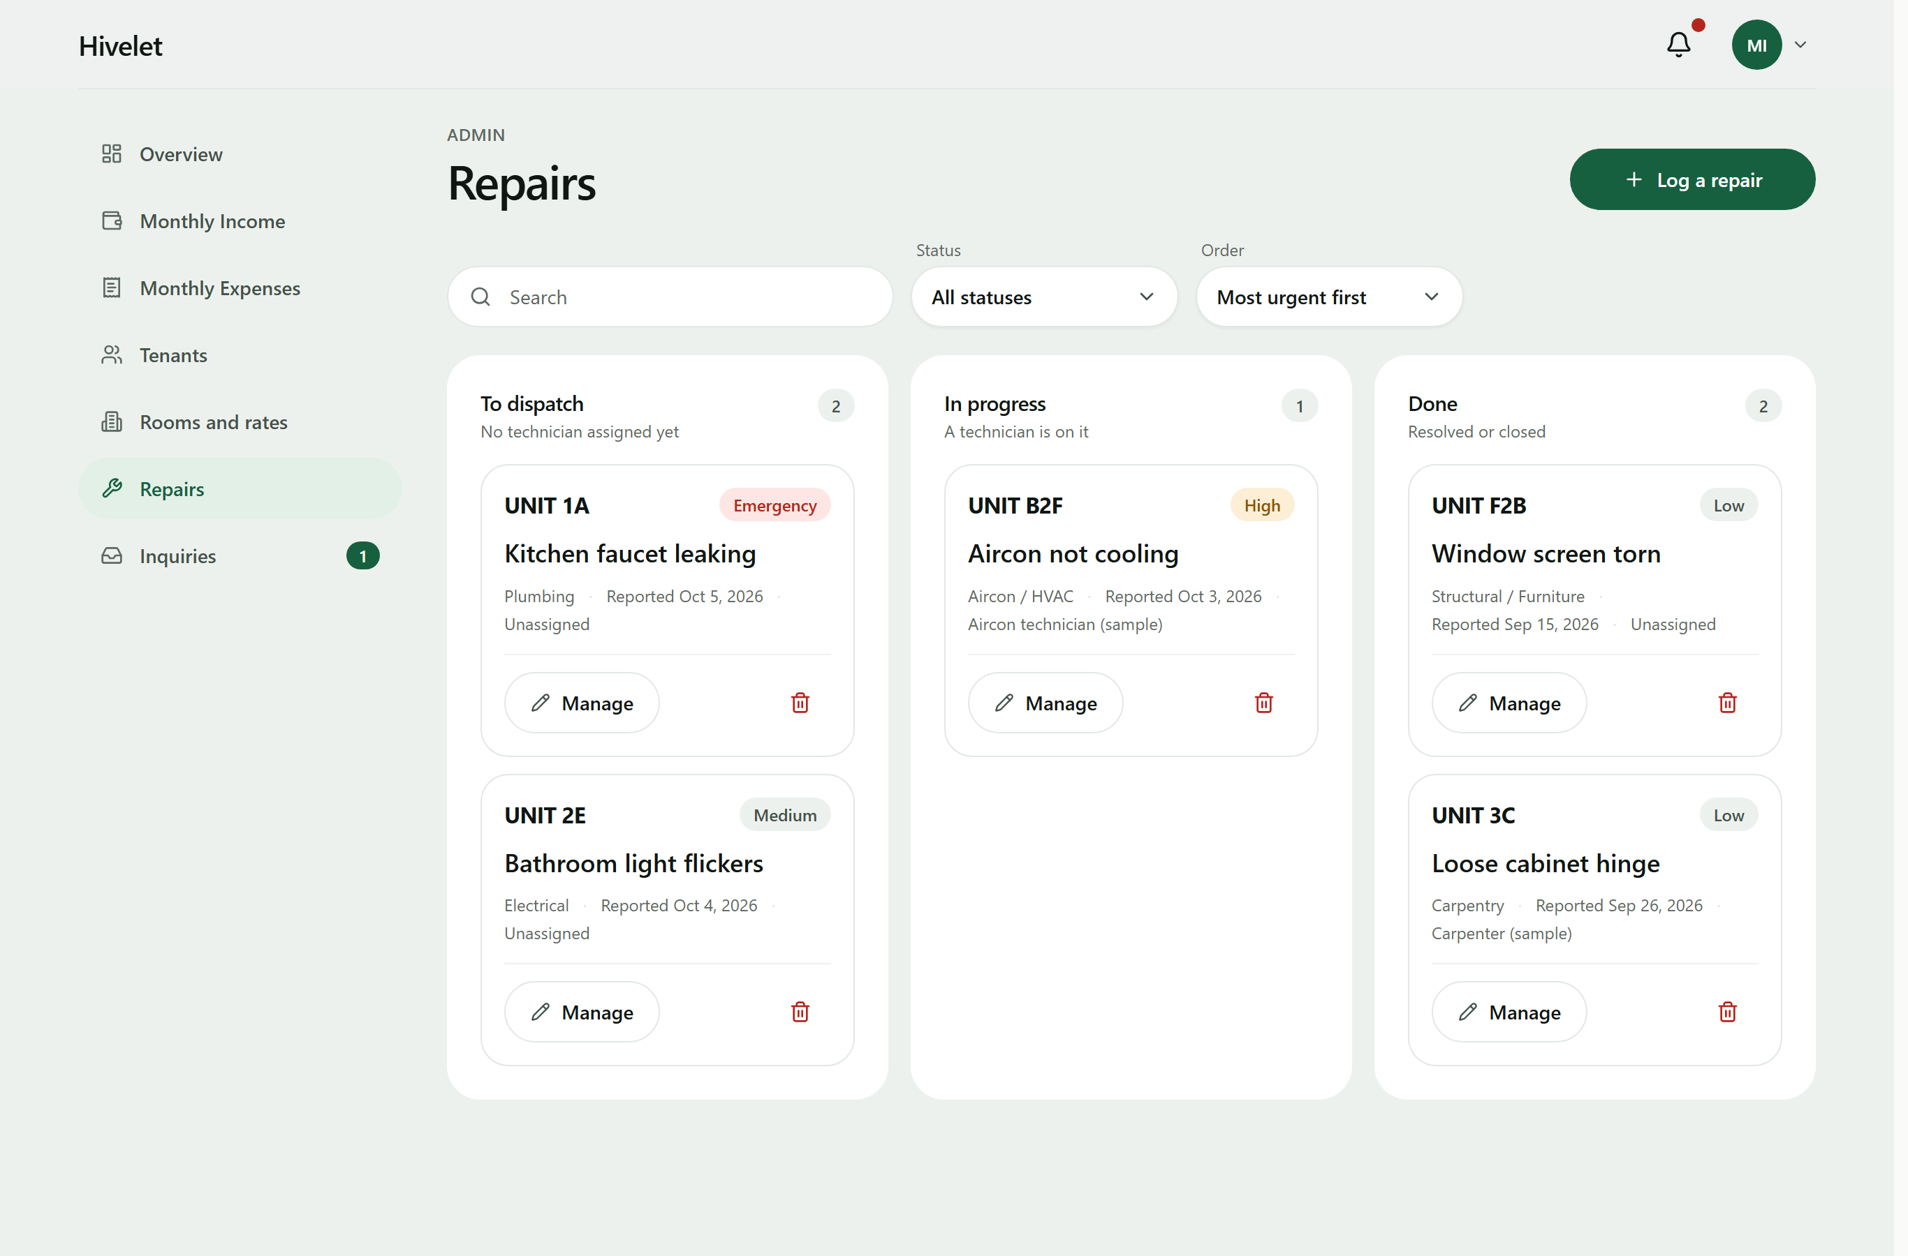
4.2.6 Role-Based Access Control
The system has the three kinds of user designed in Section 3.2.2, the public, tenants and the administrator, plus a record of each visitor who sends an inquiry (a prospect), who holds the public's rights. Every role's rights come from one permission matrix, against which each of the 55 administrator and tenant routes is checked on every verification run, and row-level security is on for every table. Table 7C sets out which role may use which function.
Table 7C. Role and privilege matrix
Function | Visitor | Tenant | Administrator
View the public site, units and rates | Yes | Yes | Yes
Send an inquiry and read the reply (private link or reference code) | Yes | Yes | Yes
View and update their own details and password | No | Own | Own
View a unit, its bills, payments and receipts | No | Own | All
Pay a bill online with GCash | No | Own | No
Send, follow and cancel a repair request | No | Own | All, and dispatch or close
Receive notifications | No | Own | Own
Manage units and rates | No | No | Yes
Manage tenants: move in, move out, reset a password | No | No | Yes
Record, verify, correct and void payments | No | No | Yes
Income and expense ledgers, overview figures and workbook downloads | No | No | Yes
Answer, close and delete inquiries | No | No | Yes

Passwords are stored as bcrypt hashes with a per-password salt; a new one needs ten characters, a letter and a number, and is refused if it appears in a public list of breached passwords. An account locks after five failed sign-ins, a new account must change its password at first sign-in, and every administrator action is written to an audit trail the application cannot edit, delete or empty. The testing of these protections is reported in Section 4.4.4.
4.2.7 Progressive Web Application Implementation
Figure 14 presents the tenant portal on a phone. The client is a Progressive Web Application with a service worker and a manifest, so it installs on a phone or computer without an app store. Installing it means adding it to the home screen from the browser (Add to Home Screen in Safari, Install app or Add to Home screen in Chrome): nothing is downloaded from a store, it opens in its own window like an application, and the application files it keeps on the device come to about 1.2 MB (as built on 13 October 2026). Since 1 and 2 October 2026 it keeps a read-only copy of the figures, names and notifications the signed-in person last loaded on that person's device, so the installed application can show them without a connection under one notice giving the time they were saved; paying and recording still need the connection, and the copy is removed at sign-out. This stays within the delimitation in Section 1.4. Screens adapt to the device, and tables on a computer become cards on a phone. As Biørn-Hansen et al. (2017) describe, one code base served every device: the owner's laptop, an Android phone in Chrome and an iPhone in Safari (Section 4.3.7).
Figure 14. The tenant portal on a mobile phone.
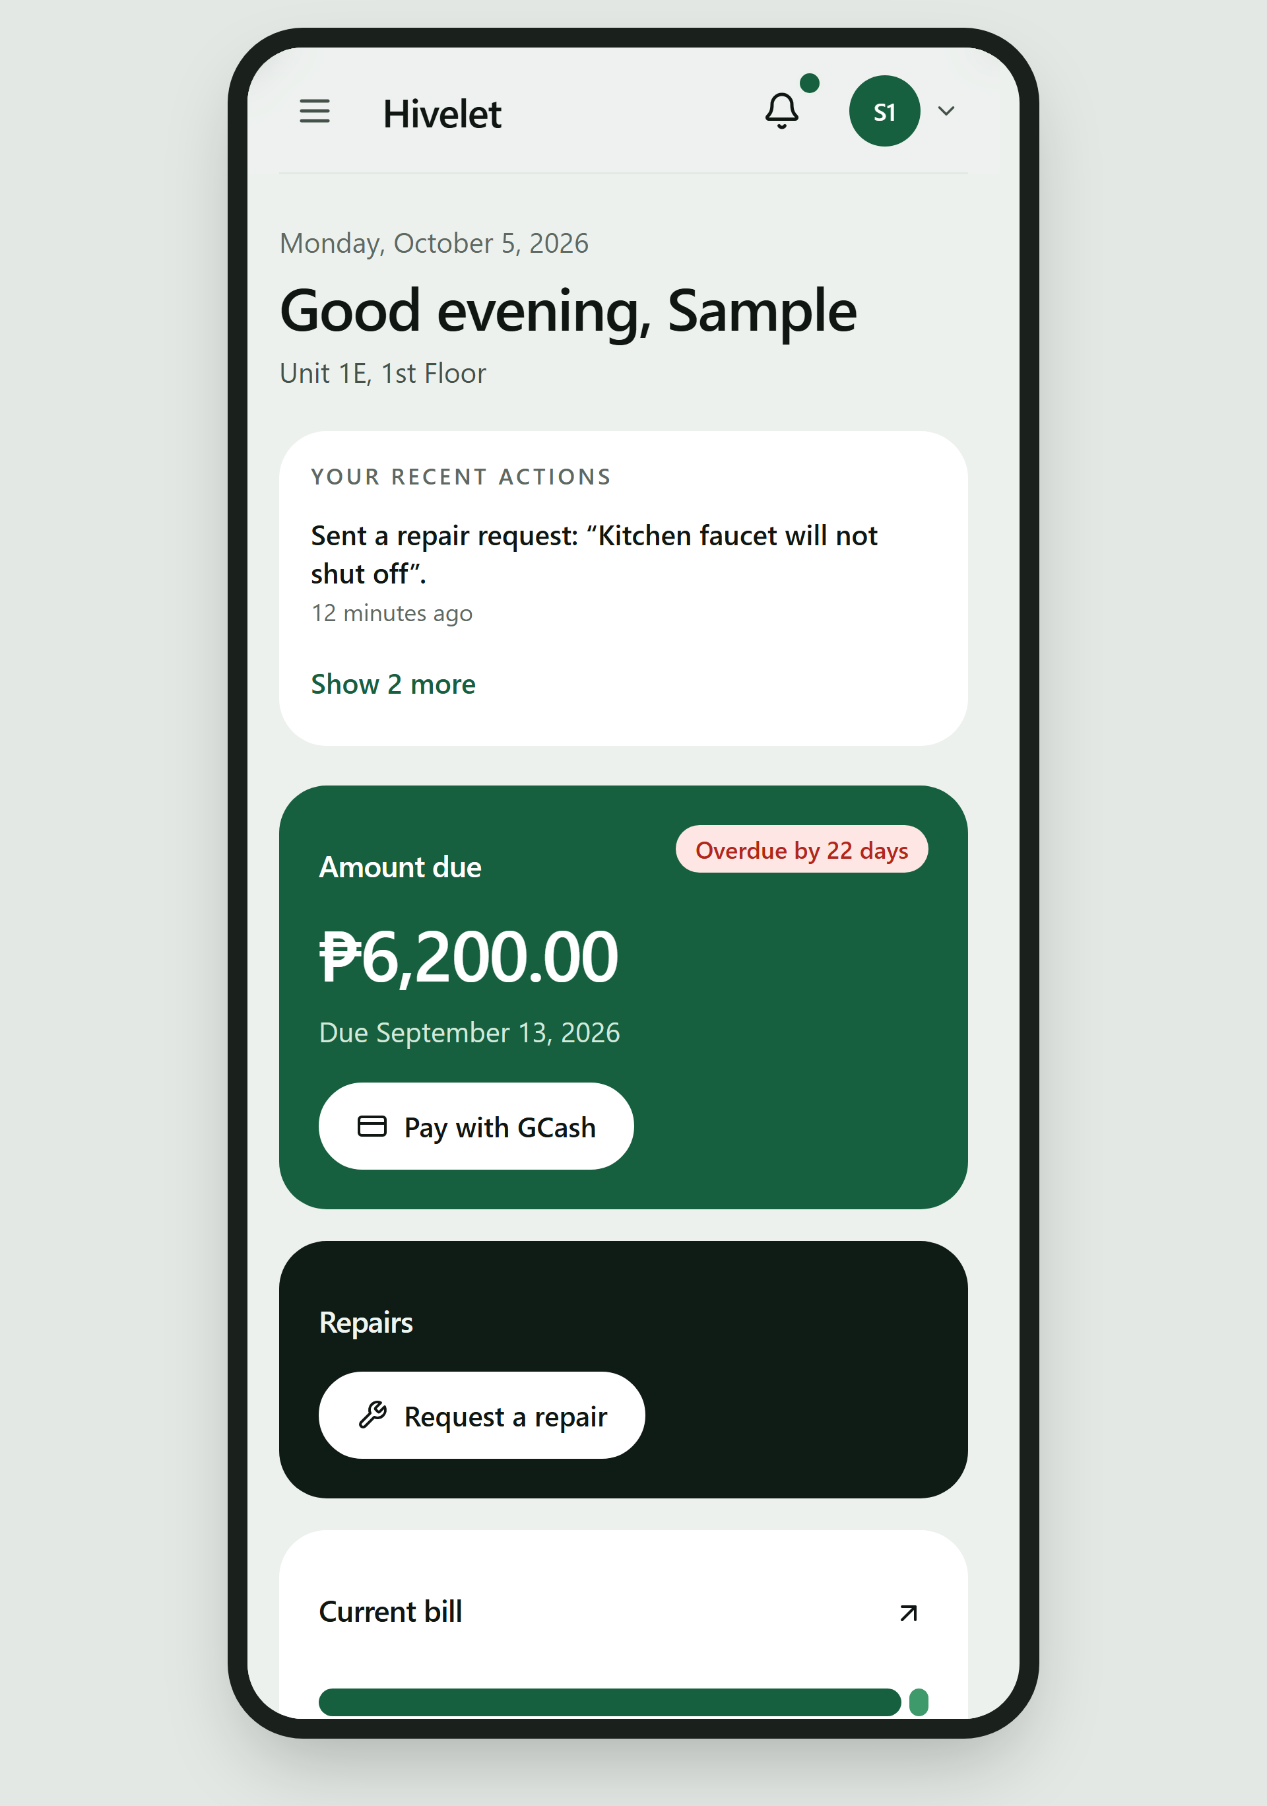
4.3 Pilot Testing of the Developed System
Answers Objective 3: functionality, responsiveness and operational performance.
The three qualities Objective 3 names are characteristics of ISO/IEC 25010:2011: functionality is Functional Suitability, responsiveness the time behavior of Performance Efficiency, and operational performance its capacity and Reliability. A test written for one quality often measures others, so Table 7D lists each test activity with every characteristic it measured. The measures are brought together by characteristic in Section 4.4.
Table 7D. Test activities and the ISO/IEC 25010:2011 characteristics they measured
Test activity (Section) | Test level | Characteristics measured (sub-characteristics)
Automated verification (4.3.1) | Unit and integration | Functional Suitability (correctness); Security (confidentiality, integrity, authenticity); Compatibility (interoperability); Maintainability (testability)
Use in the live environment (4.3.2) | System, in operation | Functional Suitability (correctness); Compatibility (interoperability); Reliability (recoverability)
Screen-versus-database audit (4.3.3) | System | Functional Suitability (correctness); Reliability (maturity)
Functional walkthrough (4.3.4) | System | Functional Suitability (completeness, correctness); Usability (user error protection); Security (confidentiality); Reliability (fault tolerance)
Responsiveness (4.3.5) | System | Performance Efficiency (time behavior, resource utilization)
Offline, installation, weak connections and simultaneous users (4.3.6) | System | Reliability (fault tolerance); Performance Efficiency (capacity); Portability (installability, adaptability); Usability (accessibility)
User acceptance testing (4.3.7) | Acceptance | Quality in use (effectiveness, efficiency, context coverage); Usability (learnability, operability); Security (confidentiality)

4.3.1 Automated Verification
Twenty automated check suites were written during development. They run against the live system and perform no writes, which is what makes them safe to run against the owner's real records. On 29 September 2026, the evening before the first test with real users, all 20 passed; Table 8 shows the principal results.
Table 8. Results of automated verification (29 September 2026)
Suite | What it checks | Result
Endpoint and access control | Every endpoint the client calls, the separation of roles, and the rejection of bad input | 78 of 78 passed
Ledger integrity | All 937 income rows against the business rules; room, tenant and occupancy agreement | Passed; 5 receipt anomalies reported for the owner
Report reconciliation | The exported Excel reports against the database, month by month | 490 of 490 passed
Payment gateway | Signature checking on gateway messages and how each kind of message is recorded | 73 of 73 passed
Record relations | That separate records agree with each other (payments with bills, tickets with units) | 30 of 30 passed
Billing arithmetic | Water, billing period and how a payment is split across bills | Passed
Data presentation | That no screen shows stored, sample or empty data as a live figure | 6 of 6 passed
Interface integrity | That every screen component exists, every input has a label, and every source file is used | Passed
Document consistency | That the requirements matrix and business rule register agree with themselves | Passed (44 requirements, 49 rules)

The checks found what nobody had written a check for: the five receipt anomalies of Section 4.1.1 came from the owner's records and are reported on every run rather than corrected, because only her invoice book can say what each should read. More important, the most serious defects found in development gave no error on screen. A cash payment could be confirmed while nothing was written to the ledger, and a partial payment could be recorded while the remaining debt was lost. Each was fixed and now has a check that fails if it returns, which is the case for automated verification in a system that holds real money: the most dangerous defects are the silent ones.
4.3.2 Use in the Live Environment
The system has run at a public address with the owner's real records since September 2026. On 22 September a checkout raised the first real bill, ₱8,200.00 for unit 1a, exactly as the rules compute it, and a test receipt voided four minutes after it was recorded returned the ledger to its 937 rows. On 23 September the owner found the system hard to use on her phone; the causes were measured (a table 518 pixels wide on a 301-pixel screen, edit buttons touch screens never showed) and fixed the same day. GCash payments were refused at first by a misconfigured acquirer account on Adyen's side, which Adyen support confirmed and replaced (Case 08657379); on 26 September a test payment passed end to end, from Adyen's authorization to the owner's verification queue. Every record the pilot tests created was then removed by one reviewed migration after a backup, leaving the owner's 937 income rows untouched.
4.3.3 Screen-versus-Database Audit
The suites prove each part correct on its own, not that a screen shows a person what the database holds for them. On 26 September 2026 a tenant's payment history read "Nothing recorded" although the tenant had seven receipts that year, while every suite passed. The team therefore compared every figure on every owner screen, and on the tenant screens on 29 September, with a read-only query of the live database for the same records. Table 9 shows the result.
Table 9. Results of the screen-versus-database audit (26 and 29 September 2026)
Screen | What was compared | Result
Owner overview | Collections for each month of 2026, the year's total, occupancy, rent per cluster, expected monthly income, operating and personal costs | Matched to the peso
Monthly Income | Totals for rent and water (and a garbage fee, removed on 30 September); collections by cluster | Matched after one defect was fixed
Monthly Expenses | Total spent, split by kind and by area | Matched; one layout defect fixed
Rooms and rates | Rent and number of occupants for each unit | Matched
Tenants | Number of tenants per cluster; move-in dates | Counts matched; one defect fixed
Activity (audit trail) | Each recent entry against the recorded action | One defect fixed
Repairs, inquiries | Number of open items | Matched
Tenant payments | A tenant's receipts for 2026 | Two defects fixed
Tenant overview, repairs and details (29 Sep 2026) | Unit, rate, occupants, monthly charge (rent plus ₱200 per occupant), the period the receipts reach, amount due, requests, contact details | Matched

The audit found six defects no automated check had caught, all fixed on 26 September: a tenant's payment history that read only online payments, rental and personal expenses in one column, a placeholder move-in date shown for every tenant, an opened checkout listed as a recorded payment, a voided receipt in a tenant's receipt list, and the Boarding House's remitted amount halved on the income screen. The lesson is the reverse side of Section 4.3.1: passing checks show that what was tested is correct, not that everything is. It qualifies Magno et al. (2024), who found that digitizing transaction tracking improves data accuracy: here every record was already digital and in one database, yet six screens disagreed with it, so digitizing alone did not make the records agree.
4.3.4 Functional Walkthrough Testing
A 26-step walkthrough, 30 rows counting its sub-steps, exercises every function that writes data once, on the one unoccupied unit so that no real record is touched. The owner performed it herself on 30 September 2026 on her laptop, signed in to her own account, with a team member reading each step; the full results are in Appendix M, Table M-1. Of the 30 rows, 24 passed the first time, 1 failed and 5 were not performed as written. Every function a tenant uses passed, as did onboarding, the duplicate guards, voiding, inquiry replies, repairs, the Excel export and moving a tenant out. The one failure was step 23b: with the connection cut, the Overview showed ₱0 where the design requires "—", so that a missing figure is never read as a zero balance; re-tested on the owner's laptop on 13 October 2026, it passed (Table 23A). A rate change and its reversal were skipped, and an expense split across two areas was entered as two expenses, so splitting, editing and deleting an expense were not exercised by the owner.
4.3.5 Responsiveness and Operational Performance
Response times were measured on 30 September 2026 on the live system, on a Dell XPS 15 laptop in Google Chrome 154 over the boarding house's Wi-Fi and on an iPhone 15 in Safari over mobile data, from the tap until the figures the user came for were on screen (Table 11).
Table 11. Page load and response times (30 September 2026, seconds)
Screen | Laptop (Dell XPS 15, Chrome 154, Wi-Fi) | Phone (iPhone 15, Safari, mobile data)
Public home page, first load | 1.85 | 2.42
Public home page, second load | 0.62 | 0.95
Sign-in to dashboard | 2.10 | 2.88
Income ledger, one full year | 1.45 | not measured
Excel export of one year | 2.30 | not measured
Tenant portal, first load | 2.15 | 3.05
Tenant payments page | 1.20 | 1.78
Sending a repair request | 1.65 | 2.10

Every screen was usable within about three seconds on the phone and a little over two on the laptop, the slowest being the tenant portal's first load (3.05 seconds on the phone). Google's PageSpeed Insights, emulating a mid-range phone on slow 4G, scored the public page 85 to 88 with its largest element at 3.4 to 3.6 seconds, and 100 for accessibility; on the owner's Overview, Lighthouse found the page moving as its figures arrived (a layout shift of 0.22) and 0.7 seconds of script work on the phone (Chapter 5, recommendation 5).
4.3.6 Offline Use, Installation, Weak Connections and Simultaneous Users
On 29 September 2026 the live system was measured with no connection, on a weak one, once installed, and with many requests at once, using an automated browser in phone emulation with every save blocked so that nothing was written to the owner's records. Table 11A gives the results without a connection and once installed. Table 11B gives those of a load test in which a script played several users at once, each pausing between requests as a person reading does; these were simulated users, not people (the owner and tenants together are reported in Section 4.3.7).
Table 11A. Offline and installation behavior (29 September 2026)
Test | Result
Installation requirements (manifest, service worker, icons) | Met; the service worker keeps 67 application files on the device after the first visit
Opening ten addresses with no connection | The application opened on all ten in about 1.5 seconds instead of the browser's "no internet" page
Tenant and administrator pages with no connection, signed out | The application opened and asked for sign-in; no personal or financial data was shown
Notice when the connection drops | Shown at once: "No connection. You can read what is already loaded, but nothing can be saved or paid until it is back."
Notice when the connection returns | "Back online"
Public unit list with no connection | Shown from the device's memory
Public unit list when the server stops answering | Shown from the device's memory after 3.1 seconds
Public page on a slow connection (400 kbps, 400 ms), first visit | Units on screen after 4.6 seconds
The same page, returning visitor | Units on screen after 0.3 seconds, because the installed application already holds its files

Table 11B. Simulated simultaneous users, read operations (29 September 2026)
Test | Simulated users at once | Duration | Requests | Errors | Slowest 5% took longer than
Public pages and public data, live site | 12 | 60 s | 1,085 | 0 | 0.52 s
The owner's ten main data requests, live database | 6 | 45 s | 285 | 0 | 0.80 s

The application opens without a connection and says plainly what it cannot do, and under loads several times the property's own no request failed and nineteen in twenty were answered in under a second. The tests found one weakness: on a weak signal a page could wait for minutes with no message. A limit was added that evening, so that a page stops after 25 seconds and says it could not reach the server, and a save stops after 45 seconds and says it cannot tell whether the save arrived, so the reader should check before sending it again. An accessibility scan of the public pages (axe-core 4, WCAG 2 A and AA) at phone and computer widths found no violation, nor did the same scan of the owner's eight screens.
Simultaneous saves. Reading at the same time tests capacity; saving at the same time tests correctness, because two requests that arrive together can each pass a check before either has been saved. This was tested by sending the same request several times in the same instant, which reproduces a double click, a retry after a timeout, or two people pressing Save together, with closer timing than people can produce by hand (Table 11F).
Table 11F. Simultaneous saves (19 and 24 September 2026)
Test | Before the change | After the change
The same receipt sent twice at once, live system | Both saved: 2 rows | 1 saved, 1 refused: 1 row
The same receipt sent five times at once, live system | All five saved: 5 rows | 1 saved, 4 refused: 1 row
One receipt covering three months, live system |  | Saved as 3 rows, June to August 2026, as before
Two GCash checkouts opened on one bill at once, payment code with a stand-in database | Both opened, so both payments could be recorded | 1 opened, 1 refused
A checkout 16 minutes after one was abandoned |  | Opened: an abandoned checkout holds the bill for 15 minutes, not for good

Neither fault showed an error, and neither could be fixed in the program alone, since a check followed by a save can always be outrun. Each fix is a rule in the database, which refuses the second save whatever order the requests arrive in, so ten requests arriving together meet the same refusal as two. Since 12 October 2026 a twenty-first suite repeats these tests on every run against the system's own request handlers; it passes 15 checks, and each of four deliberate faults made it fail. Two limits remain: the rule covers receipts with an invoice number, so two identical receipts without one, or two acknowledgement receipts, arriving at the same instant would both be saved, which the payment form's confirmation step makes unlikely without ruling out; and two people changing the same record in different ways at once was not tried.
4.3.7 User Acceptance Testing with the Owner and Tenants
The owner and three tenants used the live system for their own tasks on 30 September 2026, each on their own device and account, after giving written consent, by the procedure in Section 3.3. Where an observer's sheet and the system's activity record disagreed, the activity record was used. Table 11C gives each task's result.
Table 11C. Tenant task results (30 September 2026)
Task | Tenants attempting | Completed without help | Completed with help | Not completed | Median time (s) | Mean wrong turns | Completion without help
First sign-in and choosing a password (T-01, T-02) | 3 | 4 | 2 | 0 | 120 | 0.5 | 67%
Finding their unit, rent and balance (T-03, T-04) | 2 | 3 | 1 | 0 | 90 | 0.5 | 75%
Finding their payments (T-05, T-06) | 2 | 4 | 0 | 0 | 60 | 0.0 | 100%
Sending a repair request with a photo (T-07 to T-09) | 3 | 7 | 0 | 0 | 90 | 0.0 | 100%
Following up a request (T-10, T-11) | 2 | 3 | 0 | 0 | 120 | 0.0 | 100%
Checking their details and notifications (T-12, T-13) | 3 | 5 | 0 | 0 | 60 | 0.2 | 100%
Opening the GCash payment (T-14) | 2 | 2 | 0 | 0 | 120 | 0.0 | 100%
Staying out of the owner's pages; signing out (T-15, T-16) | 2 | 3 | 0 | 0 | 60 | 0.0 | 100%
All tasks | 3 | 31 | 3 | 0 | 60 | 0.2 | 91%

Every task the tenants attempted was completed, 31 of 34 attempts without help (91 percent). Help was needed only at the start: two of the three tenants were helped through their first sign-in and one to find their unit and rent; everything else, from finding payments to reporting a repair and opening the GCash payment, was done alone in one to two minutes. The repairs they sent reached the owner at once, and she acted on them the same evening. Mia et al. (2024) name limited technical capacity as a barrier when small Philippine enterprises adopt digital tools; these results place it precisely, in the first two things a new user does. The tests that needed several tenants saving at once were not performed, because only two attended together; in the session in which the owner and two tenants used the system at the same time, every screen loaded, each tenant saw only their own unit, the owner's full year of Monthly Income opened in about three seconds, and no session affected another (Appendix M, Table M-22). On two phones the offline behavior matched Table 11A, except that the Android phone showed the "cannot tell whether it was saved" message after 60 to 80 seconds instead of 45; corrected on 1 October, it was on time when re-tested on that phone on 13 October 2026 (Table 23A).
Table 11E brings the testing together by the test levels of ISO/IEC/IEEE 29119 (Section 3.2.4).
Table 11E. Summary of test execution by level
Level | Activity (source) | Executed | Passed | Failed | Not performed or not applicable | Pass rate
Unit and integration | Automated check suites, 29 September 2026 (Table 8) | 20 | 20 | 0 | 0 | 100%
System | Functional walkthrough by the owner, 30 September 2026 (Appendix M, Table M-1) | 25 | 24 | 1 | 5 | 96%
Acceptance | Tenant tasks, 30 September 2026 (Table 11C) | 34 | 34 | 0 | 0 | 100% (91% without help)
Acceptance | Simultaneous use by the owner and tenants (Appendix M, Table M-22) | 4 | 4 | 0 | 3 | 100%
All levels |  | 83 | 82 | 1 | 8 | 98.8%

Every level passed at least 96 percent of the tests executed, against the course standard of 90 per cent. The one failure, at the system level, was not critical, and no critical defect was found in any activity. Table 23A, in Section 4.4.6, lists the defects by activity, severity and disposition.
4.4 Evaluation of the System Based on ISO/IEC 25010
Answers Objective 4.
The evaluation followed the five steps of ISO/IEC 25040 (Table 12B), on the quality model of ISO/IEC 25010:2011. That edition was used because the approved proposal (Section 3.3) named its eight characteristics as the evaluation criteria, and the instrument was built on them; the same edition is used in Chapter 3 and here. Each characteristic was judged on measured quality, the results of Section 4.3 expressed as measures of its sub-characteristics in the manner of ISO/IEC 25023, and on rated quality, a survey in which each item belongs to one sub-characteristic (Chapter 3, Table 4B). Each respondent group rated only what it can judge: tenants did not rate Security or Maintainability, prospective tenants rated neither, and only technical evaluators rated Maintainability, the group with the background to judge it.
Table 12B. The evaluation process, following ISO/IEC 25040
Step | What it required | How it was carried out
1. Establish the evaluation requirements | The purpose, the product, the quality model and who judges it | Objective 4; the live system at its public address; ISO/IEC 25010:2011, eight characteristics; the owner, tenants and technical evaluators (Section 3.3)
2. Specify the evaluation | The measures for each sub-characteristic, and the criteria for judging them | Measures from the tests of Section 4.3 (Table 7D); survey items assigned to sub-characteristics (Chapter 3, Table 4B); criteria: Table 13 for every mean, and for tests the course standard of at least 90 percent passed with no critical defect open
3. Design the evaluation | The activities, their order and schedule | Measurements on 29 September 2026; the walkthrough and acceptance test on 30 September; the technical evaluators' review on 3 October; the survey after each group's use of the system
4. Execute the evaluation | Take the measures and apply the criteria | Section 4.3 (measured) and the survey (rated; Appendix M, Tables M-2 to M-17)
5. Conclude the evaluation | Review the results, report them, and act on them | Tables 22 and 22A, and the changes made in response (Table 23)

ISO/IEC 25010 was revised in 2023, renaming Usability as Interaction Capability and Portability as Flexibility and adding Safety. The survey was built and answered on the 2011 characteristics, so its results are reported on them; Appendix M, Table M-21, shows where each falls in the revised model.
4.4.1 Respondents
Table 12 shows the respondents by group, and Table 12A how many forms were given out and returned.
Table 12. Distribution of respondents
Group | Number | Percent
Owner / administrator | 1 | 16.67%
Tenants | 3 | 50.00%
Technical evaluators | 1 | 16.67%
Prospective tenants | 1 | 16.67%
Total | 6 | 100%

Table 12A. Instrument administration and response rate
Group | Distributed | Retrieved | Valid | Response rate
Owner / administrator | 1 | 1 | 1 | 100%
Tenants | 3 | 3 | 3 | 100%
Technical evaluators | 1 | 1 | 1 | 100%
Prospective tenants | 1 | 1 | 1 | 100%
Total | 6 | 6 | 6 | 100%

Six people answered, each after using the system and giving consent: the prospective tenant and the three tenants on 30 September 2026, after their tasks in Section 4.3.7, the owner that night after her walkthrough, and one technical evaluator on 4 October, the day after the evaluators' review. No member of the development team was among them. Three of the four groups have one respondent each, so for those groups a mean is one person's rating, and the results describe how these six people rated the system, not a sample from which a wider population can be inferred.
4.4.2 Interpretation of Scores
Each item was rated on the five-point scale in Table 4, and means are read using Table 13. The composite of each characteristic is the mean of its group means, so that one owner is not outweighed by three tenants on functions only she uses, and the overall mean is the mean of the eight composites. Averaging every response together instead gives 4.55 rather than 4.53, with the same interpretation and ranking. Table 13A works one weighted mean in full, WM = Σ(f × w) / N.
Table 13. Interpretation of mean scores
Mean score | Verbal interpretation
4.21 – 5.00 | Very High Quality
3.41 – 4.20 | High Quality
2.61 – 3.40 | Moderate Quality
1.81 – 2.60 | Low Quality
1.00 – 1.80 | Very Low Quality

Table 13A. Worked computation of a weighted mean
Rating (w) | Meaning | Frequency (f) | f × w
5 | Strongly Agree | 3 | 15
4 | Agree | 0 | 0
3 | Neutral | 0 | 0
2 | Disagree | 0 | 0
1 | Strongly Disagree | 0 | 0
Total |  | N = 3 | Σ(f × w) = 15

Indicator: "I can see my own unit details, my bill, and what I still owe." (Functional Suitability, rated by tenants). WM = 15 / 3 = 5.00, which Table 13 reads as Very High Quality.
4.4.3 Results by Characteristic
Table 22 summarizes the result for each characteristic; the rating of every item by every group is in Appendix M (Tables M-2 to M-17, ratings and measured evidence for each characteristic).
Table 22. Summary of evaluation results
Characteristic | n | Composite mean | Interpretation | Rank
Functional Suitability | 6 | 4.86 | Very High Quality | 2
Performance Efficiency | 6 | 4.42 | Very High Quality | 6
Compatibility | 6 | 4.67 | Very High Quality | 4
Usability | 6 | 4.12 | High Quality | 7
Reliability | 6 | 4.62 | Very High Quality | 5
Security | 2 | 4.70 | Very High Quality | 3
Maintainability | 1 | 4.00 | High Quality | 8
Portability | 6 | 4.89 | Very High Quality | 1
Overall |  | 4.53 | Very High Quality

The six respondents rated the system Very High Quality overall (4.53), and no characteristic, and no group mean, fell below High Quality. This is the range Canlas et al. (2026) report for a Philippine dormitory system rated by the same kinds of respondents, tenants, administrators and IT professionals; here, each rating is also read beside the measured evidence for its characteristic (Section 4.4.5).
Portability was rated highest (4.89), as one code base installed on an Android phone and an iPhone without an app store. Functional Suitability followed (4.86): every feature the objective names is present, and 96 to 100 percent of the executed checks of correctness gave the right result. Security (4.70) is discussed in Section 4.4.4. Compatibility (4.67) agrees with the browser matrix, on which every combination tried worked. Reliability (4.62) agrees most closely with the testing: the technical evaluator's 3 for handling a failed request without presenting incorrect data names the one defect the testing found, the ₱0 of step 23b, since resolved. Performance Efficiency (4.42) matches the measurements: no failed request, but screens of two to three seconds on a phone.
The two lowest were rated High Quality. Usability (4.12) is the lowest of the characteristics all four groups rated. The prospective tenant gave every item 5 and the tenants 4.47, but the owner gave 3 to telling what each screen is for and to learning the system without help, and the technical evaluator gave 3 to all five items. The evaluator answered before the fourteen changes made for that evaluator's group, eleven of them about usability, and the owner learned the system with each step read to her (Section 4.3.4). Here the rating and the measurement disagree and both are right: nine tasks in ten were done without help and 76 accessibility scans of 19 screens found no violation once one defect on three screens was corrected, but those measure whether a task can be done and whether a screen is built correctly, not how easily a first-time user finds the way. Maintainability (4.00) is the lowest composite and rests on one respondent, who gave every item 4 after reviewing the running system, without inspecting its source code, so here the measurement, read from the code itself, carries more weight than the rating. The measurement agrees: the system can be checked as a whole on every change, but three database calls in four are written inside the request handlers, so the rules for one record are spread across the handlers that touch it. Both are taken up in Chapter 5, recommendation 6.
4.4.4 Security
The owner gave every Security item 5. The technical evaluator gave 5 to role restriction, to a tenant being kept out of administrative data and to the audit trail, 4 to authentication and session handling, which agrees with two low-risk session weaknesses the code review accepted, and 3 to the handling of credentials, for which the measured evidence gives no cause and the form gave no reason. Three passive external scans graded the site A+: Qualys SSL Labs, Mozilla HTTP Observatory (all 12 tests passed once the Content Security Policy was enforced) and securityheaders.com, on 29 and 30 September 2026. Twelve checks by hand passed, among them an account locking after five wrong passwords, no personal data behind the Back button after signing out, and another tenant's repair answering "not found". A review of all 71 request handlers on 2 October found no high-severity problem, and Supabase's security advisor raised no warning on 5 October. Two weaknesses remain by design. The sign-in token is kept in the browser's storage, where an injected script could read it, which the enforced Content Security Policy and the absence of any raw HTML on the screens stand against; and sign-in takes a password only, with no second factor even for the administrator. Both are left to Chapter 5, recommendation 3.
4.4.5 Measured and Rated Evidence Together
Table 22A sets the two kinds of evidence side by side. Of the thirty-one sub-characteristics of ISO/IEC 25010:2011, twenty-seven have a measured result and twenty-five are rated by at least one survey item; two, user interface aesthetics and reusability, have neither, and no conclusion is drawn about them.
Table 22A. Measured and rated evidence by characteristic
Characteristic | Sub-characteristics | Measured | Rated | Measured result (Appendix M) | Composite mean (Table 22)
Functional Suitability | 3 | 3 | 3 | All six features present; 96 to 100 percent of correctness checks passed | 4.86
Performance Efficiency | 3 | 3 | 3 | No request failed under load; every screen usable within 3.05 s on a phone | 4.42
Compatibility | 2 | 1 | 2 | 5 of 5 device and browser combinations; gateway and spreadsheet exchange correct | 4.67
Usability | 6 | 5 | 4 | 91 percent of tasks without help; 0 accessibility violations in 76 scans | 4.12
Reliability | 4 | 3 | 4 | No critical defect; the two offline defects found on real devices, a ₱0 shown for a figure that could not load and a late message, both passed on re-test, 13 October | 4.62
Security | 5 | 5 | 3 | Every protection tried held; A+ from all three outside scanners | 4.70
Maintainability | 5 | 4 | 4 | 20 of 20 suites pass without writing to the records; every change a numbered migration; but 154 of 204 database calls inside the request handlers | 4.00
Portability | 3 | 3 | 2 | No screen wider than its window at four widths; installed on two phones without an app store | 4.89
All | 31 | 27 | 25 |  | 4.53

For seven of the eight characteristics the two kinds of evidence agree, and they disagree on Usability for the reason given in Section 4.4.3: passing measures show what was measured. Quality in use, which ISO/IEC 25010:2011 defines as the quality experienced by users in their own context, was measured by the acceptance test of Section 4.3.7 in the manner of ISO/IEC 25022: effectiveness, all 34 attempted tasks completed, 31 of them without help; efficiency, a median of 60 seconds a task with 0.2 wrong turns; and context coverage, the owner's laptop, an Android phone and an iPhone (Appendix M, Table M-20).
4.4.6 Optimization in Response to the Evaluation
Objective 4 asks for the system to be evaluated and optimized. Table 23 groups the 51 changes made in response to feedback and testing by where each finding came from; every change, with its finding and the characteristic it serves, is in Appendix M, Table M-18. Most were made the day the finding arrived, and each of the technical evaluators' fourteen comments of 3 October 2026 was addressed on the live system by 5 October.
Table 23. Optimizations made in response to evaluation, by source
Source | Changes | Characteristics served | Examples of what was found
The owner's review on a phone, 23 Sep 2026 | 4 | Usability, Portability | Edit buttons that touch screens never showed; a tenant register wider than the phone
Screen-versus-database audit, 26 Sep 2026 | 7 | Functional Suitability, Reliability, Usability, Security | A payment history showing no payments; a placeholder move-in date for every tenant
Development reviews, 26 to 28 Sep 2026 (performance, requirements, team, client, mobile, checks, final review) | 11 | Usability, Functional Suitability, Reliability, Performance Efficiency, Portability | Repairs for an empty unit; page names that differed between menu, tab and heading
Pre-testing audit and Lighthouse, 29 and 30 Sep 2026 | 5 | Usability, Security, Performance Efficiency, Reliability | One shared starting password for every tenant; no way back for a forgotten password
Testing day, 30 Sep 2026 (owner's use, walkthrough, Android phone) | 3 | Reliability, Usability | Changes not reaching the other person until a refresh; ₱0 shown with no connection
Evaluation account and security reviews, 2 and 7 Oct 2026 | 3 | Security, Functional Suitability, Reliability | A request from another website answered with a server error; breached passwords accepted
Technical evaluators' review, 3 Oct 2026 (all addressed by 5 Oct) | 14 | Usability, Functional Suitability, Security, Reliability | Filters in a pop-up with an Apply button; no way for a tenant to withdraw a request
The survey, 30 Sep to 4 Oct 2026 | 4 | Usability, Reliability, Functional Suitability | Usability items rated 3 before the evaluators' changes; a tenant asking to see the deposit
All | 51

Table 23A counts the defects found by each activity in Sections 4.3 and 4.4, by their highest severity and what became of them: critical, a wrong amount in the records or lost data; high, a wrong amount shown, a core task blocked, or an exploitable weakness; medium, a misleading display or a weakness with a workaround; low, usability, appearance or hardening.
Table 23A. Defects found, by activity, severity and disposition
Activity | Found | Highest severity | Resolved | Open or accepted
Screen-versus-database audit, 26 and 29 September (Table 9) | 6 | High: a tenant's payments not shown; a voided receipt shown as paid | 6 | None
Functional walkthrough, 30 September (Appendix M, Table M-1) | 1 | Medium: ₱0 instead of "—" with the connection cut | 1 | None: passed when re-tested on the owner's laptop, 13 October
Testing day on phones, 30 September | 1 | Medium: the "cannot tell whether it was saved" message late on Android | 1 | None: on time when re-tested on the same phone, 13 October
Check of the evaluation account, 2 October | 1 | High: online payment refused for an amount owed | 1 | None
Security review and outside probe, 2 October | 12 | High, operational: the hosting provider's visitor challenge could block payment notifications | 9 | 3 accepted as low risk: sign-in attempt limits counted per server instance, signing out not revoking a token, a wide connection policy
Technical evaluators, 3 October | 14 | Medium: phone, email and photo validation | 14 | None
All activities | 35 |  | 32 | 3 accepted

No defect found was critical. The three accepted items are low-risk session weaknesses recorded in the security audit with the reason each was accepted.
4.5 Deployment Plan and Strategies
The system is hosted on Vercel at a public web address, with the database on Supabase and the payment gateway on Adyen. Every approved change is deployed automatically from the project's main code branch. Table 24 lists what is needed to use the system, and Table 25 the deployment plan.
Table 24. Software and hardware requirements for deployment
Side | Requirement | Used in testing, 30 September 2026
Owner | A current web browser on a computer, and an internet connection | The administrator's laptop, an Acer Nitro V 15 with Chrome; the team's laptop, a Dell XPS 15 on Windows 11 with Chrome 154, Edge and Firefox 157 (Table 11, §4.4.3)
Tenants and visitors | A current web browser (Chrome, Edge, Firefox or Safari) on a phone or computer, and an internet connection | Infinix GT20 with Android and Chrome 154; iPhone 15 and iPhone 13 with Safari; the three tenants' own phones, models not recorded
Hosting | Vercel (application), Supabase (PostgreSQL database), Adyen merchant account with GCash (optional online payment) | Vercel; PostgreSQL 17.6 on Supabase; Adyen Web Drop-in 6.44 and API Library 32.0 (Table 7)
Administration | A computer that can run Node.js, used only for backups and verification runs | Node.js 22.16 on the team's Windows 11 computer

Table 25. Deployment plan and strategies
Stage | Activity | Status
1. Environment preparation | Hosting, database and gateway set up; security settings applied | Done
2. Record transfer | The owner's workbook transferred: 937 income rows and 1,327 expense allocations | Done
3. Pilot use | The system used alongside the owner's existing records; differences investigated | In progress
4. Training and hand-over | The owner and tenants shown how to use the system; user manual (Appendix K) handed over; accounts issued | Done: every tenant account prepared with its own starting password on 29 September 2026; the owner guided through the system, and the owner and three tenants using it on their own accounts, on 30 September 2026 (Section 4.3.7); the first change taken from the owner's own practice, acknowledgement receipts for payments with no invoice number, made on 1 October 2026
5. Full transition | The system becomes the owner's main record once both records agree | Not yet: as of 7 October 2026 the system has not become the owner's main record and runs beside her own records

Three risks are managed deliberately:
• The records are the owner's real financial records. A backup is taken before any change to
the data, and every change is a numbered migration that can be reviewed before it runs.
• Gateway and database credentials are kept outside the code, passed between team members
separately, and never written in any document. A check for committed credentials runs before every commit.
• The five historical receipt anomalies are kept exactly as the owner wrote them and reported
on every verification run, so they are never mistaken for errors made by the system.

